Bird Species Study

Heredity and Inheritance of Traits and Biological Evolution: Unity and Diversity,
Driving questions of unit: Kid friendly “Did you ever wonder what the Red Winged Blackbird's epaulet was FOR?”
NGSS question addressed: How do physical features within bird species help them survive and reproduce?

Question(s) | Phenomenon | Scientific Practice(s) | What We Figured Out  (DCI) - (CCC)  Common Core) | Learning goals  (Learning Performances)
5. Are some areas of the wetland better for building a nest than others? | Some areas in the wetland are better for building nests than others, . | Make observations and collect evidence  Analyzing data  Constructing claims | LS4-3 The particular habitat causes more red-winged blackbirds to be able to build nests than others.  “Area ___ would be/is better for the red-winged Blackbird to build a nest because ______. “  ccc. cause and effect | Students will collect data of the different features of the wetland and explain that the different features of the wetland would or would not meet the needs of the mother bird and her young.
Grade Level: 3
Subject: Biological Evolution: Unity and Diversity
Driving question of lesson: Is territory important to the survival of the red-winged black birds?
Topics:
Driving question of lesson: Are some areas of the wetland better for building nests than others?
Author: Miller and Severson

Usage Rights
Lesson Summary
Students make predictions about whether having higher quality territory would make a difference in reproduction and survival. Students will analyze data from their observations to determine which areas of the wetland are best for building a nest. Students will construct claims about the best areas and support their claims with evidence.

Learning performance goals: Students will model and create a graphical model of nests in chosen areas and tabulate the average number of eggs for each territory. They will discover that territory has a correlation to the number of eggs for each male’s claimed territory..
Evidence: By the end of the lesson, students can use evidence to explain why a specific area in a wetland is better for building a nest for a RWBB than another.
Assessment of science journal entry with adjustment to new evidence

Technology, Social Studies, art, music
Students will use technology to model how features create a better environment for building a nest.
Time Required
60 minute lesson.
Materials:  - Enlarged class version of ‘science story’ ( Slideshow slide 5)  - maps of the wetland  - Enlarged classroom version of map of the wetland that has the observations on it (from previous classes),  - large classroom chart and smaller versions of this chart for small group use (or you can use the slideshow slide 14)  - tokens or ‘nests’ made from paper and cut out or some other tangible symbol for a nest  - science notebooks and writing utensils,  - large photo, either on screen or otherwise of RRBB nests,  - pictures of insects RWBBs eat (optional). | Preparation:  - Place the chart and the large map and the photos around the room in prominent places. Or have them ready on your screen.  - Have a symbol or token ready for the nests.

Teacher Procedures:
- (Bring out the sentence co-created with the class during the last session. (In the slideshow this is slide 6)

The male RWBB is displaying his epaulet because it wants to warn other RWBBs to stay away because… it doesn’t want to lose its territory. My evidence is…scientists from Stanford found that when they blackened the epaulets, most of these birds lost their territory. And when bears show their teeth, they warn other bears to stay away.
- Ask the students if they can remind the class about what they discovered about RWBBs from the study. Students think-pair-share what the ‘story’ says so far. Then pick one or two students randomly to either say what they or their partner discussed.
- You have a large map of the wetland from lessons one and two with areas marked off in categories. This map also has from lesson field trip follow up features that the students observed on their field trip and observations, included where the RWBBs were sighted and where they saw nests and other physical features. Also remind them of what the nests looked like and how they were hidden. Remind them of what RWBBs eat too at this time. You can show a picture to refresh their memories. (Also in the slideshow slide 4)
Red-winged Blackbirds eat mostly insects, including dragonflies, damselflies, other flies, beetles, butterflies, and moths, as well as other invertebrates, such as spiders. They catch insects on plants, off the ground, and from the air. In the winter, they switch to mostly grains.

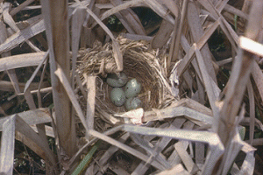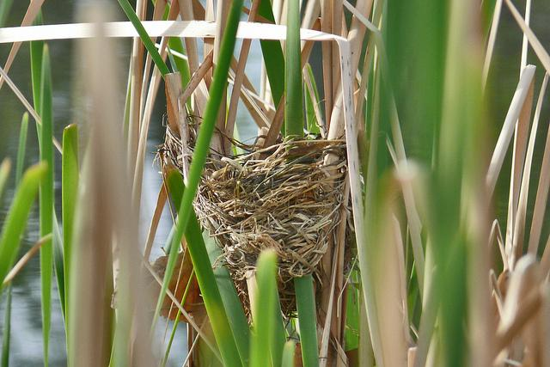
- As a class, fill out the important features on the chart from the map (sections one and two - features and sightings).
(example of possible chart for map and its features)
area | features | How many RWBB nests found? | Why would this be a good place to build a nest? | why would this not be a good place to build a nest?
A | lots of tall grass not very many trees | 3 or more | tall grass to hide nests | no water - not so many bugs
B | lots of trees | 0 | good for other birds - not RWBB | too many trees no long grass
C | lots of tall grass not very many trees, has pond, lots of bugs | > 5 | tall grass to hide nests  few trees - good for spotting danger - water for bugs to eat
D | lots of tall grass no trees | 1 | tall grass to hide nests | parking lot

- Students will go into groups of three or four to use the chart to discuss which features are the most important for a RRBB to build a nest and to fill out the last two categories. They will have ‘nests’ to put on their map as a group. (This can be markers from math class or small erasers or little cut out ‘nests’).
- When the small group is done, students should go group by group and place their ‘nests’ on the large class version. Discussions and questions from the group should be encouraged, especially if there is disagreement.
- Once all of the nests have been recorded,return to the sentence co-created from the last lesson. Explain that scientists try to tell a story of what happens in nature.
The male RWBB is displaying his epaulet because it wants to warn other RWBBs to stay away because… it doesn’t want to lose its territory. My evidence is…scientists from Stanford found that when they blackened the epaulets, most of these birds lost their territory. And when bears show their teeth, they warn other bears to stay away.
As a class, add a new sentence to the ‘story’. (Possible example of additions below in purple).
The male RWBB is displaying his epaulet because it doesn’t want to lose its territory The best territory has high grass so the nest can be hidden with only a few trees so the bird can spot danger from far away and water nearby so there is a lot of bugs my evidence is…scientists from Stanford found that when they blackened the epaulets, most of these birds lost their territory. This is like other animals because when bears show their teeth, they warn other bears to stay away.

- Students should add this sentence to their science notebooks. They can draw a picture of what features an area in a wetland should contain to be the best for building a nest for a RWBB.

Wrap up: Today we looked over the evidence from the observations from the field trip to determine whether some areas of the wetland are better than others.

Formative assessment : Students hold up one finger if they thought Area A was the best for building a nest, two fingers if they thought area B was best for building a nest and three if they thought are C was the best and four fingers if area D was the best. They should hold up five fingers if they thought there was no difference. You should be able to call on any student randomly and they can tell you why they believe it is area “X” with one or more reasons using evidence from the discussion and observations.
Commonly Held Student Ideas
- http://assessment.aaas.org/misconceptions/ENM

Differentiated instruction:

Sensory Support | Graphic Support | Interactive Support
Real-life objects (realia) | Charts | - In pairs or partners
Manipulatives | Number lines | - In triads or small group
- Pictures and photographs | ✓ Tables | Using cooperative groups structures
Illustrations & diagrams | Graphs | ✓ Using the Internet or software programs
Magazines & newspapers | Timelines | In the native language
Physical activities | Graphic Organizers: | With mentors
Video/films | ✓ Other Engineering model | sentence starters
Broadcasts | - Maps
- models and figures

Extensions:
- Parents invited to take a wetland walk with students as ‘homework’
- _{bird walks in the neighborhood}
- _{Sharing of birds sighted}
- individual reports about birds during literacy
- Students research different birds and their behavior on their own
- Students read Burgess Book for Children by Thorton W. Burgess
- Read aloud: Frightful’s Mountain by Jean Craighead George
Teacher Content Background
There are many species of Red winged black birds that live all over the world. Most live in wetlands. They are related to black birds, which live less often in wetlands. Red winged blackbird males arrive first to the wetlands to stake out their territory before the females arrive to build their nests.
Red-winged black birds are polygamous and can mate with as many as 15 different females in one mating season.
Territory is important, because the females do not choose to nest based on any characteristics of the male, but by the quality of the land and availability of food.
References: (web sites)
The national Audubon Society
Journey North Red winged black birds
Wild birds unlimited

