6-8 Performance Task Work - Life Science
Target Performance Expectations, Practices, and Crosscutting Concepts
Content Standards:
- MS-LS2-4. Construct an argument supported by empirical evidence that changes to physical or biological components of an ecosystem affect populations. [Clarification Statement: Emphasis is on recognizing patterns in data and making warranted inferences about changes in populations, and on evaluating empirical evidence supporting arguments about changes to ecosystems.]
- MS-LS2-5. Evaluate competing design solutions for maintaining biodiversity and ecosystem services.* [Clarification Statement: Examples of ecosystem services could include water purification, nutrient recycling, and prevention of soil erosion. Examples of design solution constraints could include scientific, economic, and social considerations.]

Practices: Engaging in Argument from Evidence
Engaging in argument from evidence in 6–8 builds on K–5 experiences and progresses to constructing a convincing argument that supports or refutes claims for either explanations or solutions about the natural and designed world(s). Compare and critique two arguments on the same topic and analyze whether they emphasize similar or different evidence and/or interpretations of facts. Respectfully provide and receive critiques about one’s explanations, procedures, models, and questions by citing relevant evidence and posing and responding to questions that elicit pertinent elaboration and detail. Construct, use, and/or present an oral and written argument supported by empirical evidence and scientific reasoning to support or refute an explanation or a model for a phenomenon or a solution to a problem. Make an oral or written argument that supports or refutes the advertised performance of a device, process, or system based on empirical evidence concerning whether or not the technology meets relevant criteria and constraints.

Crosscutting Concepts: Cause and effect: Mechanism and explanation
In grades 6-8, students can understand that systems may interact with other systems; they may have sub-systems and be a part of larger complex systems. They can use models to represent systems and their interactions—such as inputs, processes and outputs—and energy, matter, and information flows within systems. They can also learn that models are limited in that they only represent certain aspects of the system under study.

Scenario/phenomenon - Students will read articles describing approaches in slowing the spread of invasive species. They will make arguments, supported by evidence from those articles, as to the appropriate method for controlling the spread of an invasive species not mentioned in the articles.

Teacher Resource/ Background:
Read: or provide students with knowledge to be able to understand the difference between Containing or Shielding.

‘Containing the Threat’ by Julia Solomon in the August 2009 Wisconsin Natural Resources magazine and information on Asian Carp Control Efforts from the Wisconsin DNR.
Then read ‘Containment key in preventing aquatic invasive species, experts say’ by Jim Hansen in April 2009 in a news release by the Northern Region. 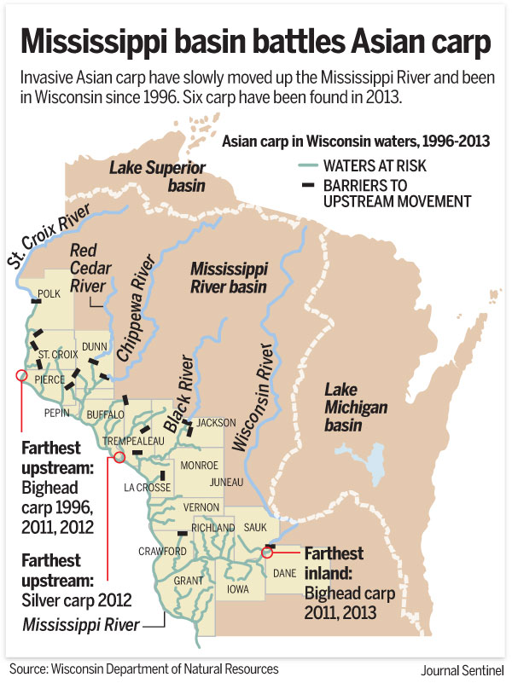

Describe the difference between ‘containing’ and ‘shielding’ in attempts to slow the spread of invasive species.

 | Containing | Shielding
Controls spread of invasive species
Has a zone that keeps the invasive species out
Has a zone that keeps the invasive species in
May include checking boats as they enter the water
May include checking boats as they leave the water
May include electric fences that keep fish from swimming up stream
Has a zone that keeps the invasive species in
Currently working for Bighead Carp
Zebra Mussels are controlled in this way
Eurasion water millfoil are controlled in this way

Why does the Wisconsin DNR approach controlling the spread of Asian Carp by ‘containing’ and approaches controlling other invasive species, such as zebra mussels, by ‘shielding’.

Task:
Wisconsin DNR is holding a meeting to discuss a plan to control the spread of emerald ash bore. You will be assigned a role of a townsperson. Prepare an CER argument based on their point of view and support the argument with evidence from the articles.

Roles: Park Ranger, CEO of Lumber yard owner, Resort Owner, Trees for Tomorrow, Hunter Guide, Land developer, One of two people who live in an apartment, Owner of a house with a large wooded lot, Cabin Owner. House on the border of the national forest, house with emerald ash bore,

Role:
Resource:

Argument: http://www.activatelearning.com/blog/2015/11/9/cer-poster-download

Claim:

Evidence:

Resaoning:

MS-LS2-4. Construct an argument supported by empirical evidence that changes to physical or biological components of an ecosystem affect populations. [Clarification Statement: Emphasis is on recognizing patterns in data and making warranted inferences about changes in populations, and on evaluating empirical evidence supporting arguments about changes to ecosystems.]
1 | 2 | 3 | +
Identifies the methods used to contain invasive species | Presents an argument to support their chosen method of containing an invasive species. | Presents an argument outlined in the article that will limit the spread of an invasive species | Presents multiple arguments outlined in the article that will limit the spread of an invasive species
MS-LS2-5. Evaluate competing design solutions for maintaining biodiversity and ecosystem services.* [Clarification Statement: Examples of ecosystem services could include water purification, nutrient recycling, and prevention of soil erosion. Examples of design solution constraints could include scientific, economic, and social considerations.]

1 | 2 | 3 | +
Lists the differences between containing and shielding against invasive species. | Chooses a method of control that is most appropriate for controlling the spread of an invasive species | Describes limitations of their approach for controlling the spread of an invasive species. | Describes limitations of their approach for controlling the spread of an invasive species and measures to mitigate those limitations.
Practices: Engaging in Argument from Evidence
Engaging in argument from evidence in 6–8 builds on K–5 experiences and progresses to constructing a convincing argument that supports or refutes claims for either explanations or solutions about the natural and designed world(s). Compare and critique two arguments on the same topic and analyze whether they emphasize similar or different evidence and/or interpretations of facts. Respectfully provide and receive critiques about one’s explanations, procedures, models, and questions by citing relevant evidence and posing and responding to questions that elicit pertinent elaboration and detail. Construct, use, and/or present an oral and written argument supported by empirical evidence and scientific reasoning to support or refute an explanation or a model for a phenomenon or a solution to a problem. Make an oral or written argument that supports or refutes the advertised performance of a device, process, or system based on empirical evidence concerning whether or not the technology meets relevant criteria and constraints.
1 | 2 | 3 | +
Defends a choice for controlling the invasive species. | Uses evidence presented in the text to support their argument. | Uses excerpts from the text to support their argument | Uses multiple excerpts from the text to support their argument
1 | 2 | 3 | +
Crosscutting Concepts: Cause and effect: Mechanism and explanation
In grades 6-8, students can understand that systems may interact with other systems; they may have sub-systems and be a part of larger complex systems. They can use models to represent systems and their interactions—such as inputs, processes and outputs—and energy, matter, and information flows within systems. They can also learn that models are limited in that they only represent certain aspects of the system under study.
1 | 2 | 3 | +
Demonstrates an understanding of the effects of attempts to control an invasive species | Outlines the challenges presented when trying to control the spread of an invasive species. | Outlines the differences between the invasive specie mentioned in the articles and their researched specie that may affect the success of their approach to controlling it. | Outlines multiple differences between the invasive specie mentioned in the articles and their researched specie that may affect the success of their approach to controlling it.

