Name __________________________________________________

Woodland  Animals | List characteristics/adaptations that help these animals survive in their habitat and why these things help them survive
fox
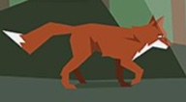
deer
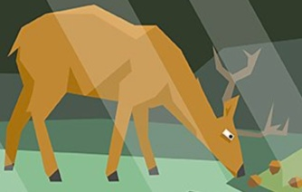
owl
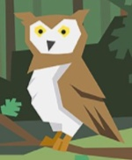

Name __________________________________________________

Polar  Animals | List characteristics/adaptations that help these animals survive in their habitat and why these things help them survive
bird
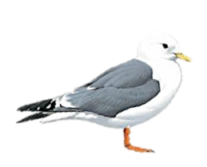
polar bear cub

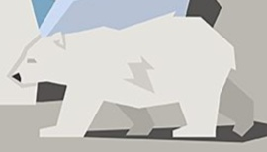

fish

