Woodland Habitat
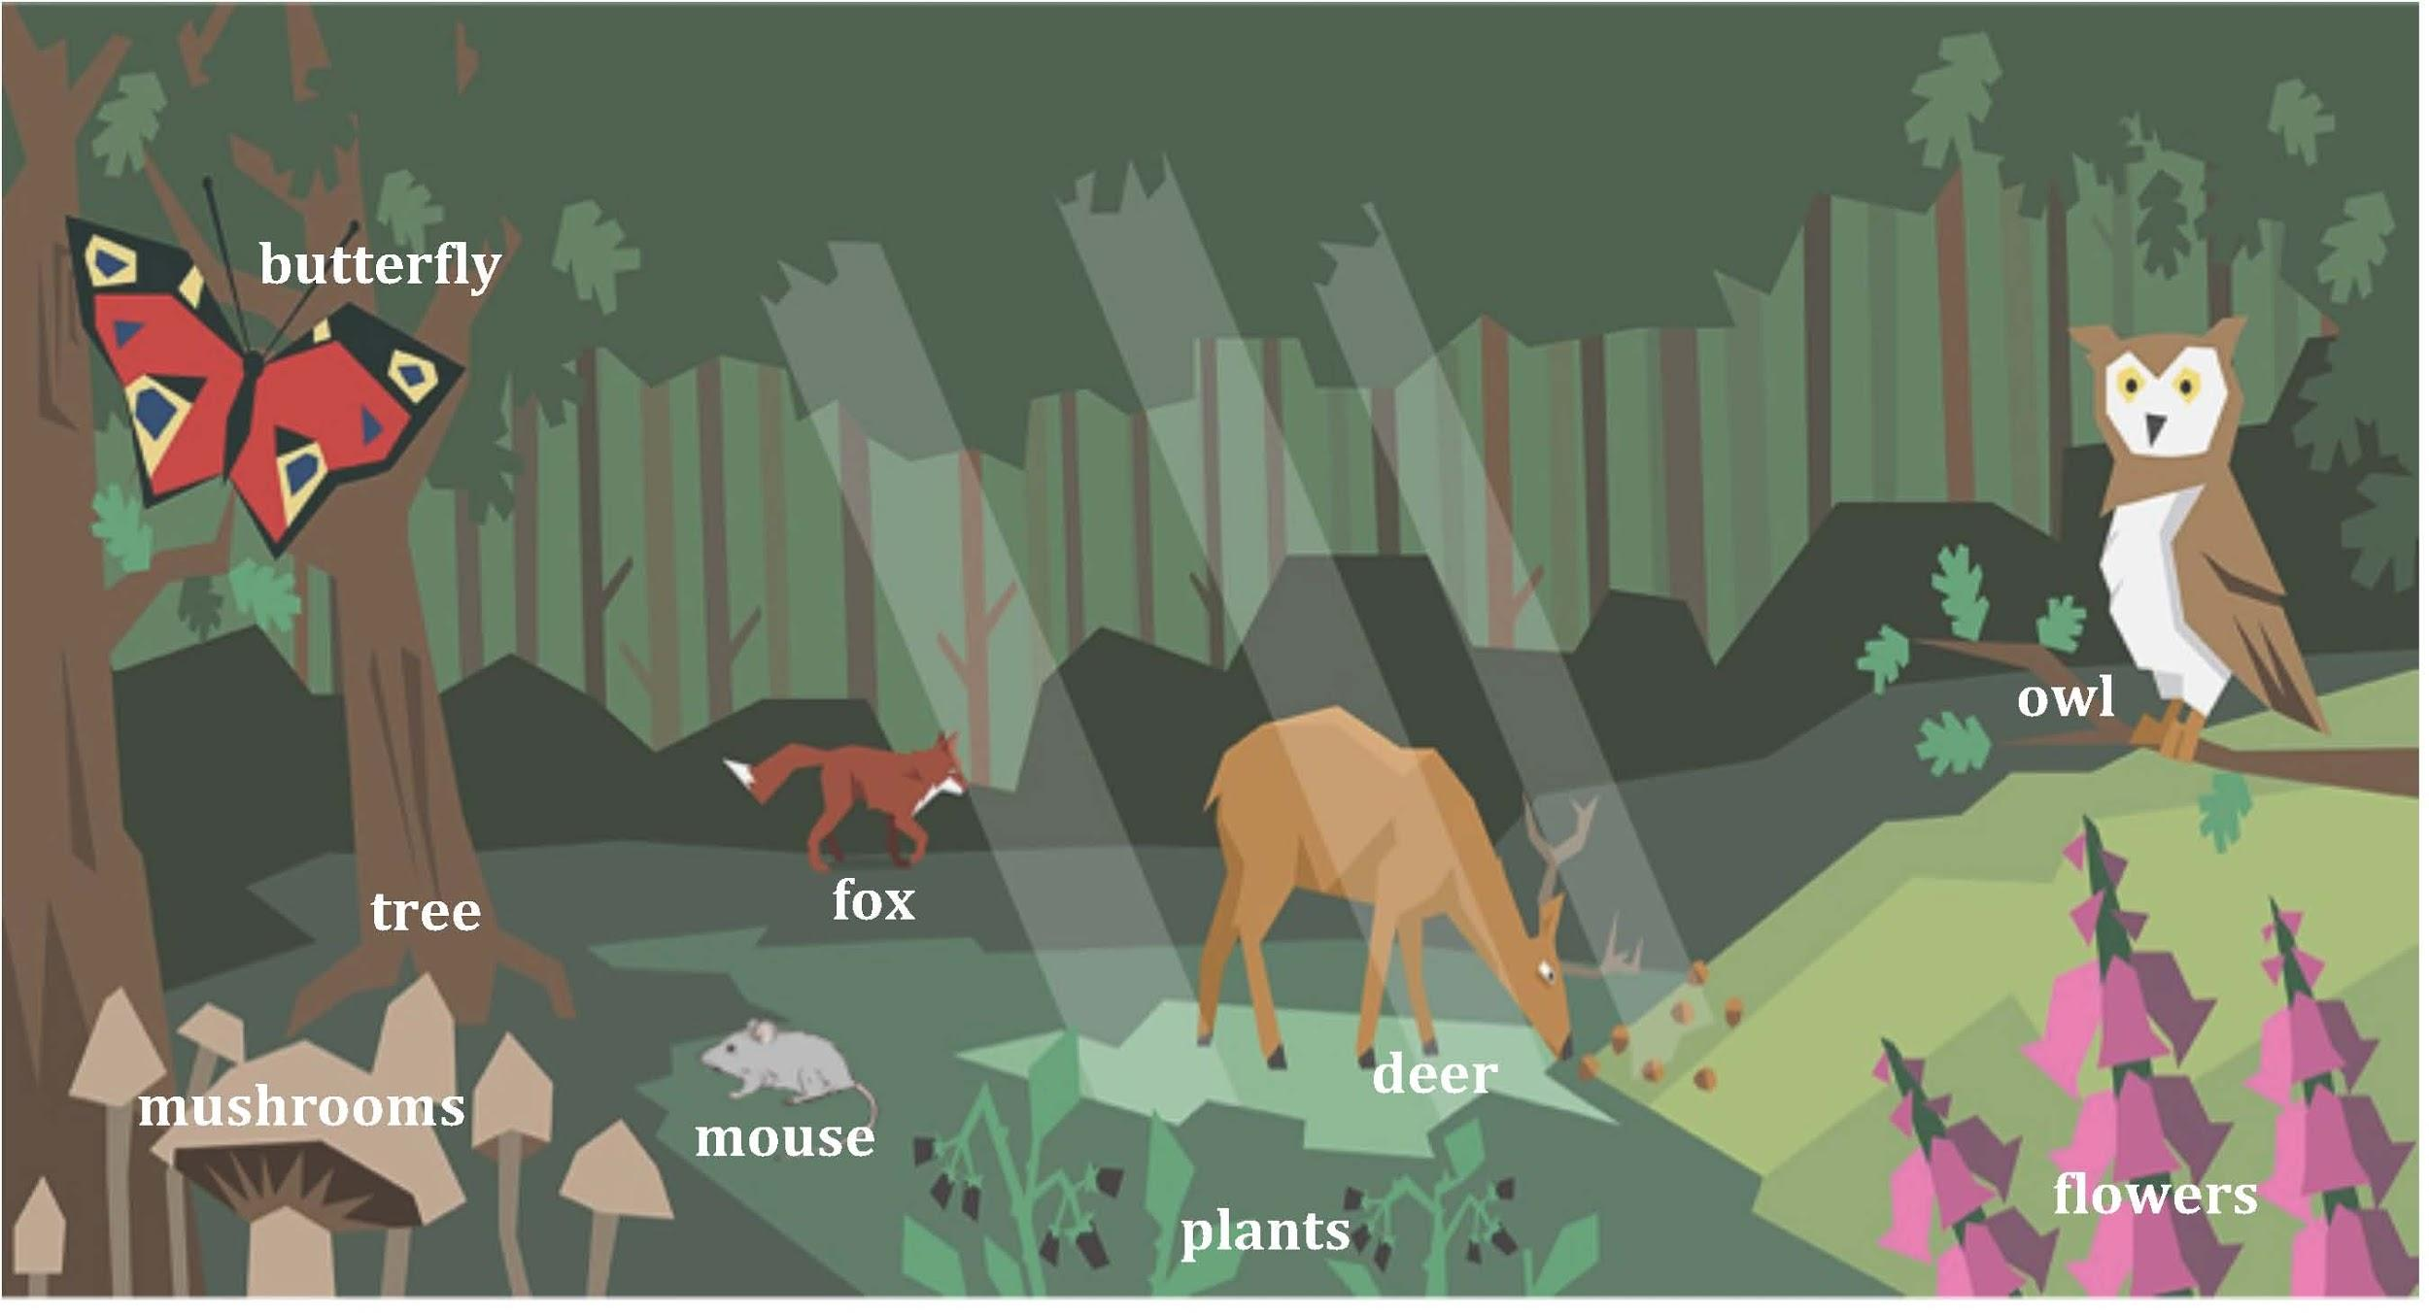
What do you notice about the living things in this habitat?

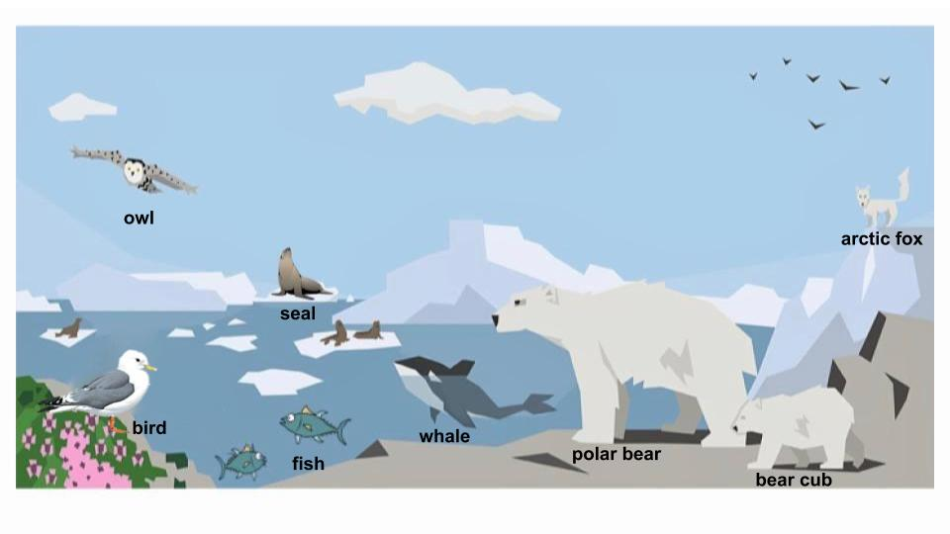
Polar Habitat
What do you notice about the living things in this habitat?

