Impact of Overfishing on Marine Ecosystems Sample Problem
Data Analysis
Danielle Bendt dbendt@marshallschools.org
Allison Fuelling afuelling@marshallschools.org
Dorothy Ginnett ginnettd@cesa5.org

Teacher Notes:
This assessment asks students to analyze the impact of overfishing on marine ecosystems. Students should have experience in analyzing graphs and food webs/marine ecosystems.

Anchor Phenomenon: Overfishing in Marine Ecosystems

Applicable NGSS Standards:

PE - Performance Expectation (primary PE focus):
HS-LS2-6 | Evaluate the claims, evidence, and reasoning that the complex interactions in ecosystems maintain relatively consistent numbers and types of organisms in stable conditions, but changing conditions may result in a new ecosystem.  [Clarification Statement: Examples of changes in ecosystem conditions could include modest biological or physical changes, such as moderate hunting or a seasonal flood; and extreme changes, such as volcanic eruption or sea level rise.]  (For more detail on this standard from the NGSS@NSTA Hub, see HS-LS2-6)
Unpacking the 3-Dimensions:
DCI - Disciplinary Core Idea:

SEP - Science & Engineering Practices:
Engaging in Arguments from Evidence and Using Mathematics and Computational Thinking

CCC - CrossCutting Concepts: Stability and Change and Cause and Effect

Learning Outcomes:
- Students will use global fisheries data to analyze trends in fisheries catch effort and fisheries harvest
- Students will use global fisheries data to analyze the impact of overfishing on marine ecosystems
- Student arguments about global fisheries data are supported by claims, evidence and reasoning

See the HS-LS2-L6 Evidence Statements

Impact of Overfishing on Marine Ecosystems Student Handout

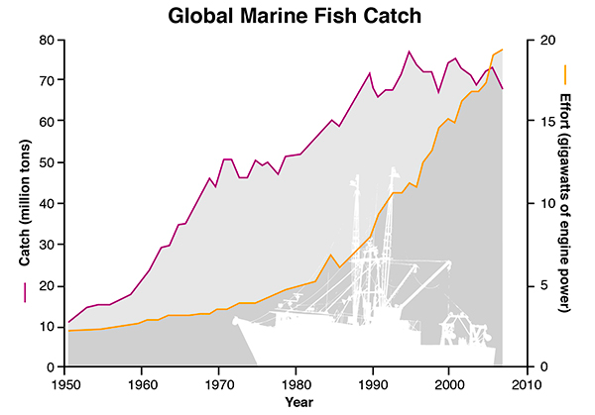
Humans have increasingly looked to the ocean for a food source. Increases in technology have produced larger boats with more horsepower and the capacity to travel farther distances. The graph below shows both the amount of human effort (as measured by engine power) and the size of the marine (ocean) fish catch since 1950.

Global Marine Fish Catch from 1950 to 2010. Over 90% of the world’s assessed fisheries have met or exceeded their biological limits (FAO, 2014). While the global reported catch has leveled out since the early 1990s, fishing effort has steadily increased since the 1970s, suggesting stock declines in most fisheries. The global fish catch (purple line) has declined in recent years, even though fleets are spending more effort (orange line) to catch fish. Source: Sea Around Us Project.

Source of graph: Global Marine Fish Catch

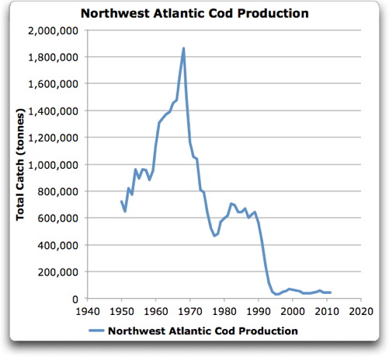

Cod are a favorite fish of many restaurant-goers. The total catch from the Northwest Atlantic region is illustrated to the right. Of course, people eat more than just cod. The graph below indicates the increase in total fish consumption since 1950s.

Source of graph: Northwest Atlantic Cod Production

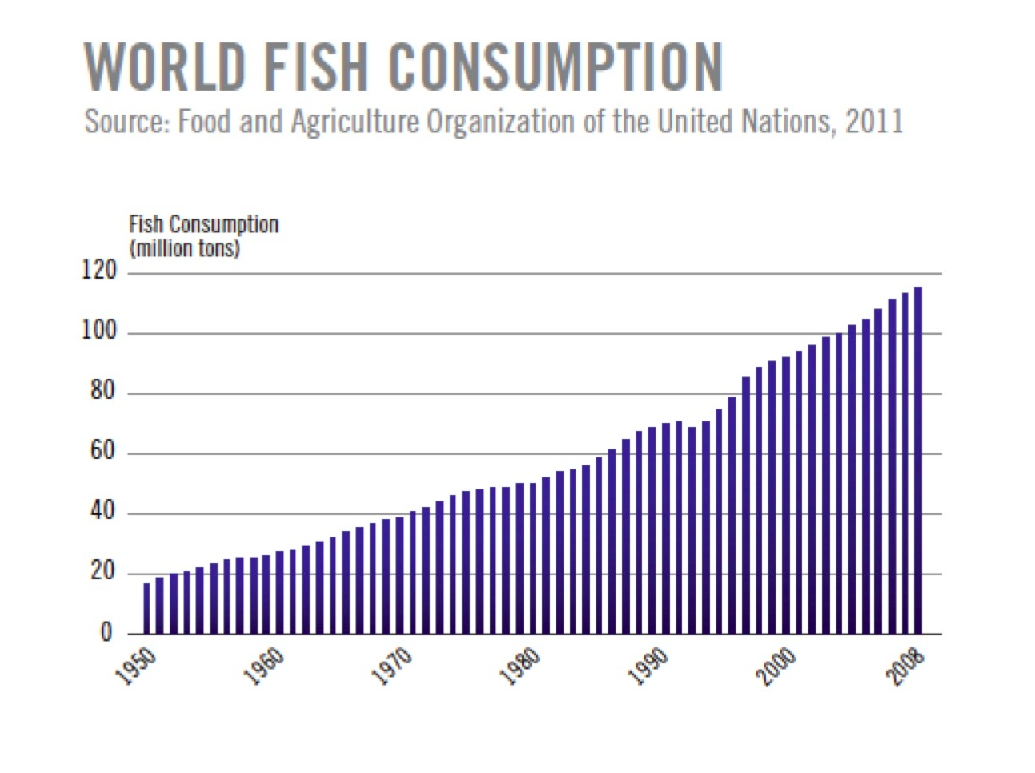

Source of graph:World Fish Consumption

Question | Your Answer
1. Describe the general trend in engine power needed to catch fish over the past 60 years.

2. Using the graphs provided, what might be a factor that contributed to your trend described in question #1? Make sure to describe how your factor is related to engine power.

3. Determine the rate of change in the Global Marine Fish Catch between 1950 and 2000.

4. The top graph shows that the total amount of fish caught has increased, while the second graph shows that the amount of cod (a type of fish) has decreased drastically over the same time. How can the cod harvest decrease while the total harvest has increased?

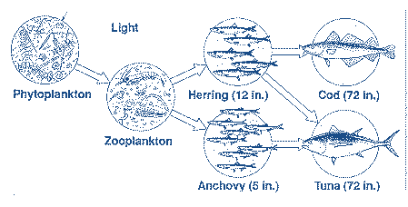
5. Cod are predators in the food web as shown below. As the number of cod harvested increases, predict what impact this will this have on at least 2 other species in the food web and explain your reasoning.

Source of food web graphic

Using Mathematics and Computational Thinking Rubric
Needs Improvement | Basic | Proficient | Exemplary
I can identify general trends in variables. | I can determine the relationship between variables (eg: linear, exponential). | I can mathematically describe the relationship between variables (eg: calculate rates of change, construct equations that relate variables).  I can evaluate reliability of data, consider limitations of data analysis, or be able to distinguish between causal and correlational relationships. | I can evaluate the impact of new data on the working explanations and/or model of a proposed process.
Teacher Note - each question is mapped to a level of proficiency in this rubric
In question 1:  Students can identify that engine power has increased over the last 60 years. | In question 2:  Students relate the increased engine power required to the increased demand on fish harvest  *Note - students might cite other reasons for increased engine power (increased size/speed of boats, increased distance to fishing areas)... the point of this activity is to have students base their response on evidence presented here. | In question 3:  Students determined the rate as approximately 0.26 gigawatts/year (rise in gigawatts = 13 divided by 50 years).  In question 4:  Students state that while the proportion of cod has decreased, the overall harvest has increased… other fish species would make up the remaining portion of the harvest. | In question 5:  Students would relate loss of a top predator to changes in the population size of other species in the given food web. Claims are supported with evidence.  Proposed answers include:  Tuna - increase in population because no competition from cod in hunting herring  Herring - increase in population because they would have fewer cod predators  Zooplankton - decrease in population because of increased herring population (see above)

