Name: ________________________

Impact of Overfishing on Marine Ecosystems

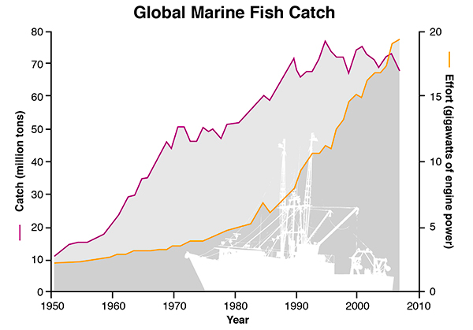
Humans have increasingly looked to the ocean for a food source. Increases in technology have produced larger boats with more horsepower and the capacity to travel farther distances. The graph below shows both the amount of human effort (as measured by engine power) and the size of the marine (ocean) fish catch since 1950.

Global Marine Fish Catch from 1950 to 2010. Over 90% of the world’s assessed fisheries have met or exceeded their biological limits (FAO, 2014). While the global reported catch has leveled out since the early 1990s, fishing effort has steadily increased since the 1970s, suggesting stock declines in most fisheries. The global fish catch (purple line) has declined in recent years, even though fleets are spending more effort (orange line) to catch fish. Source: Sea Around Us Project.

Source of graph: Global Marine Fish Catch

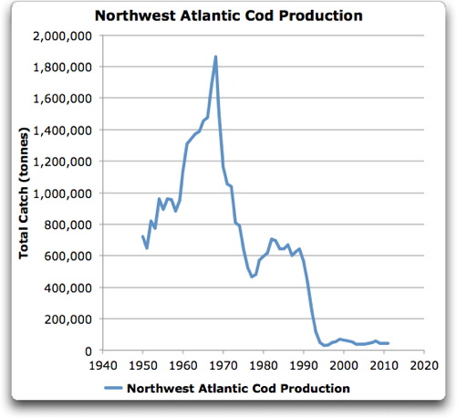
Cod are a favorite fish of many restaurant-goers. The total catch from the Northwest Atlantic region is illustrated to the right. Of course, people eat more than just cod. The graph below indicates the increase in total fish consumption since 1950s.

Source of graph: Northwest Atlantic Cod Production
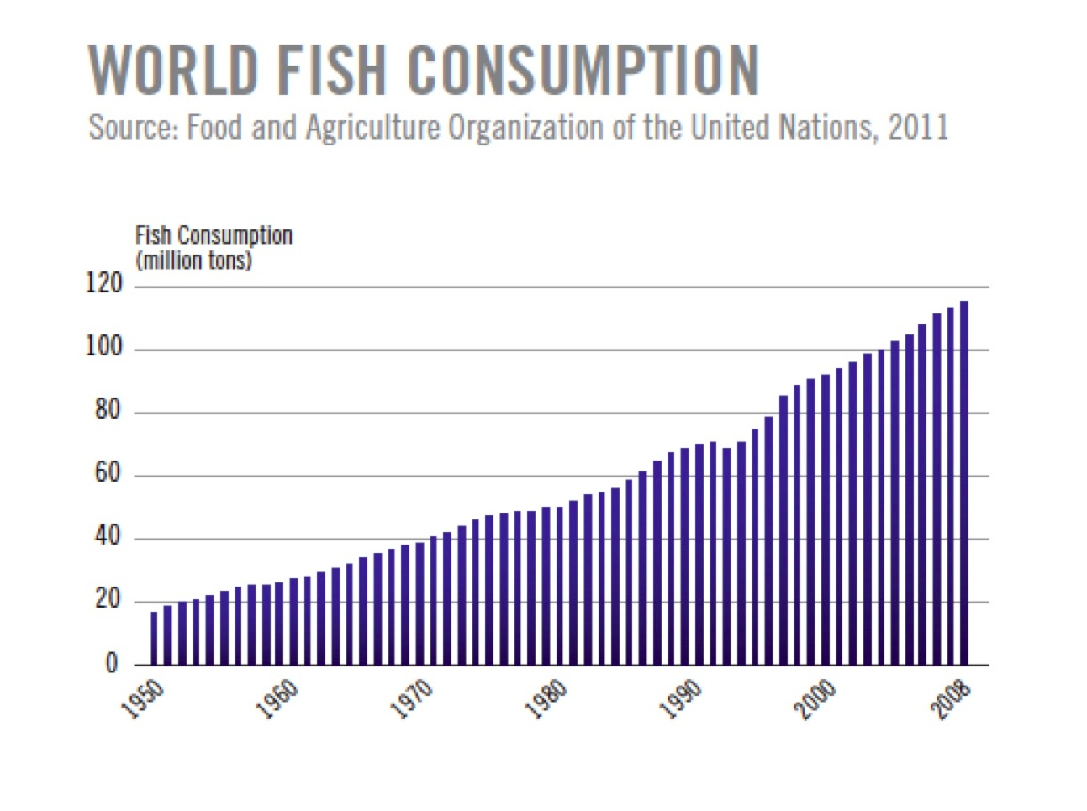

Source of graph:World Fish Consumption

Question | Your Answer
1. Describe the general trend in engine power needed to catch fish over the past 60 years.

2. Using the graphs provided, what might be a factor that contributed to your trend described in question #1? Make sure to describe how your factor is related to engine power.

3. Determine the rate of change in the Global Marine Fish Catch between 1950 and 2000.

4. The top graph shows that the total amount of fish caught has increased, while the second graph shows that the amount of cod (a type of fish) has decreased drastically over the same time. How can the cod harvest decrease while the total harvest has increased?

5. Cod are predators in the food web as shown below. As the number of cod harvested increases, predict what impact this will this have on at least 2 other species in the food web and explain your reasoning.
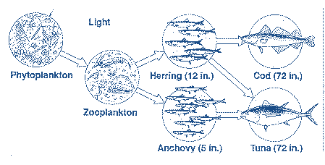
Source of food web graphic

