Fourth Grade Energy and Collisions - Teacher Notes

Next Generation Science Performance Expectation

4- PS3-3 Ask questions and predict outcomes about the changes in energy that occur when objects collide. [Clarification Statement: Emphasis is on the change in the energy due to the change in speed, not on the forces, as objects interact.] [Assessment Boundary: Assessment does not include quantitative measurements of energy.]

This performance task assumes that students have a basic understanding of energy and speed.

Intended Purpose

- formative assessment - post learning opportunity
- summative assessment
- performance task - using given data provided on activity sheet
- may be used as a teacher demonstration

Possible Modifications

- performance task - students do experiment with modified activity sheet - remove data and personalize to your students
- modify mass of marble or cup - only change one at a time
- steepness of the ruler

Application/Extension

Page 3 (slide questions) are intended to be used as an application or extension. Modifications may be made to personalize for your students: ski jump, bike jumping, skateboarding, etc.

Phenomenon: Energy and Collisions 4th Grade
SEPs: Asking Questions, Analyze and Interpret Data, Mathematical Thinking
PEs: 4-PS3-3

Scenario: A marble rolled down a ruler will push an object. A student is curious about this. The student sets up a ruler as a ramp and releases a marble down the ramp. The marble enters and hits the back of a cup that is placed at the end of the ramp. The student notices that when the marble hits the cup, the cup slides.

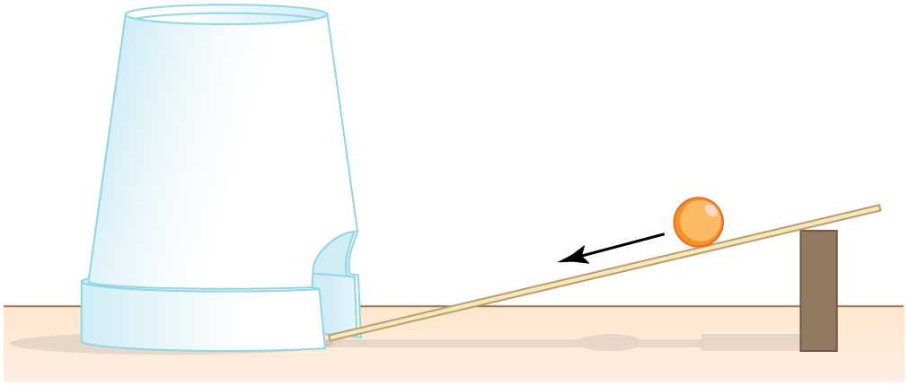
Image: https://cooljargon.com/ebooks/physics/m42150/index.cnxml.html

1. A student did this experiment. What is a question you think she was trying to answer?

Experiment: The student does the experiment by releasing the marble from different points along the ruler.

2. Predict what will happen to the cup when the marble is released from different spots on the ruler.

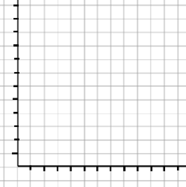
The results of the student’s experiment are given in the table below.
Position of marble release (ruler mark) inches Distance cup moved inches  3 2  6 4  9 6  12 8 | Distance cup moved  Position of Marble
Position of Marble Release
3. Make a graph (bar graph or line graph) of the data on the axes to the right of the table.

4. Based on the data what did the student find out.

5. How does the student’s result compare to your prediction?

6. A. Describe the motion of the marble before the collision

B. Describe the motion of the cup before the collision

C. Describe the motion of the marble and cup after the collision

7. Explain why the motion of both the marble and cup changes. Support your explanation with evidence.

Performance Task Extension

8. Think about the following event that took place at the local water park last summer. Jimmy and Johnny are identical twins that are the same size and weight. Jimmy climbs to the top of the ten foot slide; Johnny climbs to the top of the twenty foot slide. Each of the boys slides down the slide and splashes into the pool.

A. Who lands further from the end of his slide? Johnny or Jimmy?

B. Defend your choice based on what you learned from the marble activity above.

C. Which of the boys makes a bigger splash? Johnny or Jimmy?

D. Defend your choice based on what you learned from the marble activity above.

3-5 Physical Science Energy and Collisions Rubric

4- PS3-3 Ask questions and predict outcomes about the changes in energy that occur when objects collide. [Clarification Statement: Emphasis is on the change in the energy due to the change in speed, not on the forces, as objects interact.] [Assessment Boundary: Assessment does not include quantitative measurements of energy.]

 | 4 | 3 | 2 | 1
4-PS3-3: | Ask questions, Identifies variables related to the questions and outcomes including multiple transfers of energy. | Asks questions and predicts outcomes about the changes in energy that occur when objects collide relative to changes in speed. | Asks questions and predicts outcomes that are related to scenario but not testable. | Asks questions and predicts outcomes that are unrelated to the scenario.
SEPs:  Analyzing and Interpreting Data | Represents data in tables and line graphs and analyzes and interprets data to provide evidence for phenomena. Makes predictions from the graphed data. | Represent data in tables and bar graphs, recognizes patterns in the data, analyzes and draws conclusions about the meaning. | Represents data in tables and graphs and recognizes patterns in the data. | Tabulates and graphs data with inaccuracies apparent.

