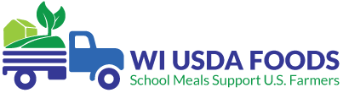
SY 2022-23 Wisconsin USDA Foods Networking and Training Schedule
Live Microsoft Teams meetings will be held four to five times per year on Wednesdays from 2:00-3:00 PM CST. Training topics will correlate with the WI USDA Foods Program Timeline.
Click on the “Live Meeting Link” below to join the meeting. After the date of the live event, the link will convert to a recording and be available for School Food Authorities (SFAs) to view for 90 days.
Month | Training Topic
September 7  Live meeting link | - Looking up Orders in the WI USDA Foods Ordering System  - Reporting Order Discrepancies for State Delivery  - Checking Direct Diversion Pounds at Distributor and Processor  - Updating the Application Tab Contract and Delivery Location  - Inventory Management
November 1-2  Join in person! | - Fall SNA-WI Conference  - Direct Diversion  - Procurement
January 25  Live meeting link | - USDA Foods Google Preference Survey Results for SY 2023-24 Direct Delivery (Brown Box)
February 8  Live meeting link | - USDA Foods Annual Order Survey Training SY 2023-24
May 3  Live meeting link | - Annual Order Updates and Viewing Adjustments  - End-of-Year Reconciliation

