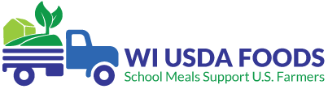
SY 2021-22 Wisconsin USDA Foods Networking and Training Schedule
Live Microsoft Teams meetings will be held four to five times per year on Wednesdays from 2:00-3:00 PM CST. Training topics will correlate with the WI USDA Foods Program Timeline (https://dpi.wi.gov/school-nutrition/usda/timelines).
Click on the “Live Meeting Link” below to join the meeting. After the date of the live event, the link will convert to a recording and be available for School Food Authorities (SFAs) to view for 90 days.
Month | Training Topic
September 8  Live Meeting Link | - Looking up Orders in the WI USDA Foods Ordering System  - Reporting Order Discrepancies for State Delivery  - Checking Direct Diversion Pounds at Distributor and Processor  - Updating the Application Tab Contract and Delivery Location  - Inventory Management
November 2-3  Meeting Link | - Fall SNA-WI Conference  - Direct Diversion  - Procurement
January 26  Live Meeting Link | - USDA Foods Google Preference Survey Results for SY 2022-23 Direct Delivery (Brown Box)
February 9  Live Meeting Link | - USDA Foods Annual Order Survey Training SY 2022-23
May 4  Live Meeting Link | - Annual Order Updates and Viewing Adjustments  - End-of-Year Reconciliation

