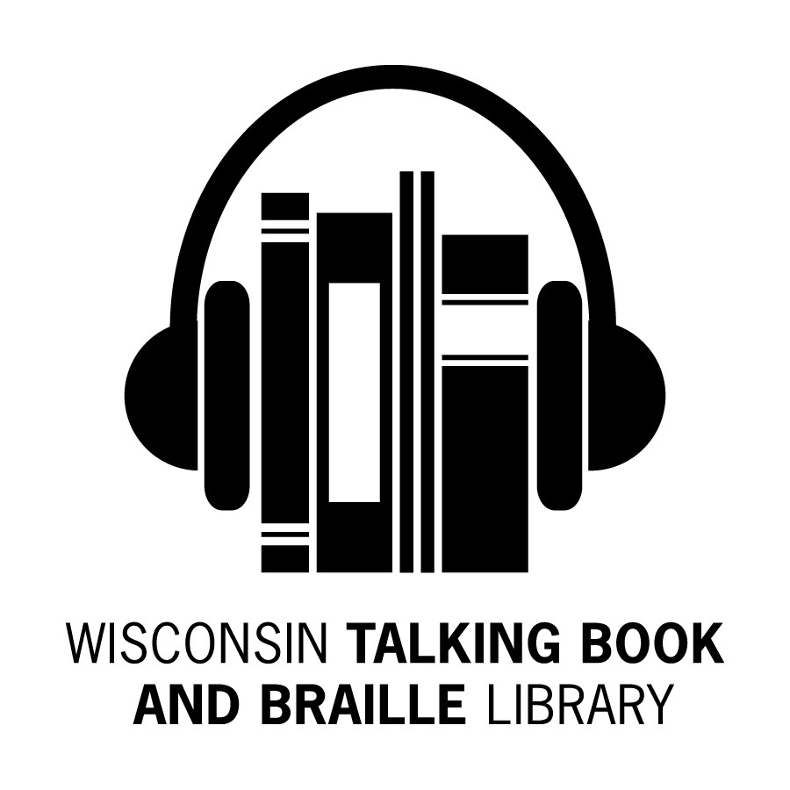
Bulletin Board Newsletter

Fall 2014

What’s Been Happening at the WTBBL!

Hello Readers! The summer has been a busy time for us here. We’re updating patron records and inventorying our collection.

We would like to know how we are doing and what we can do better. As part of assessing our services to you, you’ll find a patron survey in this newsletter. You can respond in a number of ways:
- fill out the paper survey and return it by mail or email;
- fill it out online at www.surveymonkey.com/s/wtbblwi; OR
- call WTBBL and a staff member will help you.

We’ve contracted with ABLE (Audio & Braille Literacy Enhancement) to record more Wisconsin books and are pleased to announce updated braille, large print and audio formats of the WTBBL audio-described DVD catalog.

Did you know that October 15th, 2014 will be the 50th anniversary of White Cane Safety Day? Jean Kenevan (OBVI) and others around the state are organizing celebrations. There is a Vision Loss booklist in this Bulletin Board issue.

On the home front, WTBBL has welcomed three new staff members: Paul, Sylvia and Trevonna. We congratulated Jerry, one of the Library Clerks, when he took a promotional transfer to the Forestry Department.

For those of you who use the Internet, please “like” us on Facebook and check out the updated booklists on WTBBL’s website talkingbooks.wi.gov

Keep reading and talking about us to your friends. We love to keep you reading,

Linda

Ruling in Authors Guild v. HathiTrust

In June 2014, the court ruled clearly and unambiguously that libraries may provide full digital access to the books in their collections to patrons who are blind or print disabled, and that providing such access is a fair use of copyrighted works under our nation’s copyright laws. You can learn more about this victory at: www.hathitrust.org/around_the_web

Newsletter by Email

Would you like to receive the WTBBL newsletter by email instead of on paper? If so, please call 1-800-242-8822 or email wtbbl@milwaukee.gov and let us know. The newsletter is also available on our website at talkingbooks.wi.gov or on digital cartridge.

Updated DVD Catalog

You can request an updated audio-described DVD catalog in large print, braille, or on digital cartridge. Some of the new titles include:

• DVD00750 The Monuments Men
• DVD00744 The Hunger Games: Catching Fire
• DVD00720 The Croods
• DVD00724 Frozen
• DVD00747 12 Years a Slave
• DVD00715 The Wolf of Wall Street
• DVD00732 My Bionic Pet

WTBBL on Facebook

WTBBL now has a Facebook page to share news, photos, reviews, and updates about the library. Log into Facebook, find Wisconsin Talking Book and Braille Library and like us today!

New Wisconsin Titles Available

ABLE (Audio Braille and Literacy Enhancement) has produced more Wisconsin books for your listening enjoyment. Here are recent additions:

• DBW09401 9XM Talking: WHA Radio and the Wisconsin Idea by Randall Davidson
• DBW09400 Why Not Wisconsin? From Barry to Bo: Broadcasting the Badgers from the Best Seat in the House by Matt Lepay
• DBW09399 A Liberal in City Government: My Experiences as Mayor of Milwaukee by Frank P. Zeidler
• DBW09397 Truck: A Love Story by Michael Perry
• DBW09395 The Devil’s Highway: A True Story by Luis Alberto Urrea
Need a Speaker or Have an Upcoming Event?

If you are a member of a group that would like a presentation about WTBBL, please call us. Our outreach librarian, Becky Manz, would be happy to visit your group or facility and discuss our library services. We can also set up an exhibit table at a health fair or conference and demonstrate the digital player and highlight some of the services that WTBBL offers. Look for us this fall at the Brain Injury Resource Fair, the Interfaith Senior Centers Resource Fairs, and the Institute on Aging’s Annual Colloquium. Call Becky at 1-800-242-8822 to set up an outreach event.

50th Anniversary of White Cane Safety Day
By Jean Kenevan, Office for the Blind and Visually Impaired

This year marks the 50th anniversary of White Cane Safety Day in Wisconsin and nationwide. Since 1964, this national observance is celebrated annually on October 15th.

On October 6th, 1964, a joint resolution of the U.S. Congress H.R. 753 was signed into law. This resolution authorized the President of the United States to proclaim October 15th of each year as "White Cane Safety Day".

The date was designated to acknowledge the achievements of people who are blind or visually impaired and heighten public awareness of the white cane as a tool used by persons who are blind or visually impaired to gain mobility and independence.

In honor of the 50th Anniversary of White Cane Safety Day, various groups throughout Wisconsin and the nation will be organizing events in their communities to bring safety awareness to the public and celebrate White Cane Safety Day.

In recognizing the importance of white cane safety, Wisconsin has enforced a traffic law since 1947. White Cane Safety Day acknowledges the law based on the following statute:

S. 346.26 WISCONSIN STATUTES
(1) An operator of a vehicle shall stop the vehicle before approaching closer than 10 feet to a pedestrian who is carrying a cane or walking stick which is white in color or white trimmed with red and which is held in an extended or raised position or who is using a service animal, as defined in s. 106.52(1)(fm), and shall take such precautions as may be necessary to avoid accident or injury to the pedestrian. The fact that the pedestrian may be violating any of the laws applicable to pedestrians does not relieve the operator of a vehicle from the duties imposed by this subsection.

The Wisconsin Talking Book and Braille Library celebrates White Cane Safety Day with all blind and visually impaired residents of Wisconsin. Following here is a list of books about vision loss and people with vision loss. Please contact WTBBL to request any of these books.

WTBBL BOOKLIST – Fall 2014

Vision Loss

- DB076495 Macular Disease: Practical Strategies for Living with Vision Loss by Peggy R. Wolfe
- DB074495 Macular Degeneration: A Patient’s Guide to Treatment by David S. Boyer and Homayoun Tabandeh
- DB070278 One Hundred Questions and Answers about Macular Degeneration by Jeffrey S. Heier
- DB073854 Sites Unseen: Traveling the World without Sight by Wendy S. David
- DB077851 For the Benefit of Those Who See: Dispatches from the World of the Blind by Rosemary Mahoney
- DB066055 Self-Esteem and Adjusting with Blindness: The Process of Responding to Life’s Demands by Dean W. Tuttle and Naomi R. Tuttle
- DB065093 Seeing Beyond Blindness by Shelley Kinash
- DB071922 Learning to Cope with Sight Loss—6 Weeks at a VA Blind Rehabilitation Center by William L. McGee and Sandra V. McGee
- DB078044 Blinded by Sight: Seeing Race through the Eyes of the Blind by Osagie K. Obasogie

Biographies Dealing with Vision Loss
- DB061948 No End in Sight: My Life as a Blind Iditarod Racer by Rachael Scdoris and Rick Steber
- DB071033 The Ballad of Blind Tom by Deirdre O’Connell
- DB071626 Borges: A Life by Edwin Williamson
- DB072707 Inside My World by Larry Johnson
- DB073300 Thunder Dog: The True Story of a Blind Man, His Guide Dog, and the Triumph of Trust at Ground Zero by Michael Hingson and Susy Flory
- DB076189 Blind But Now I See: The Biography of Music Legend Doc Watson by Kent Gustavson
- DB077282 Trusting Calvin: How a Dog Helped Heal a Holocaust Survivor’s Heart by Sharon L. Peters
- DB076560 Beyond the Bear: How I Learned to Live and Love Again after Being Blinded by a Bear by Dan Bigley and Debra McKinney
- DB077130 Second Suns: Two Doctors and Their Amazing Quest to Restore Sight and Save Lives by David Oliver Relin
- DB070651 Going Blind: A Memoir by Mara Faulkner
- DB068883 Surpassing Expectations: My Life without Sight by Lawrence Scadden

WTBBL BOOKLIST – Fall 2014

Vision Loss Books for Children and Young Adults
- DB073569 Dead End Bluff by Elizabeth Witheridge
- DB030566 Business is Looking Up : Featuring Renaldo Rodriguez by Barbara Aiello and Jeffrey Shulman
- DB067181 Hanni and Beth: Safe and Sound by Beth Finke
- DB067059 Ray Charles: “I Was Born with Music Inside Me” by Carin T. Ford
- DB065682 Vision Without Sight: Human Capabilities by Susan Brocker
- DB069606 The World at His Fingertips: A Story About Louis Braille by Barbara O’Connor
- DB070876 Follow My Leader by James B. Garfield
- DB070466 To the Rescue: Found Dogs with a Mission by Elise Lufkin
- DB066527 She Touched the World: Laura Bridgman, Deaf-Blind Pioneer by Sally Hobart Alexander and Robert Joseph Alexander
- DB061308 From Charlie's Point of View by Richard Scrimger
- DB054713 Things Not Seen by Andrew Clements
- DB055570 Blind Sighted by Peter Moore

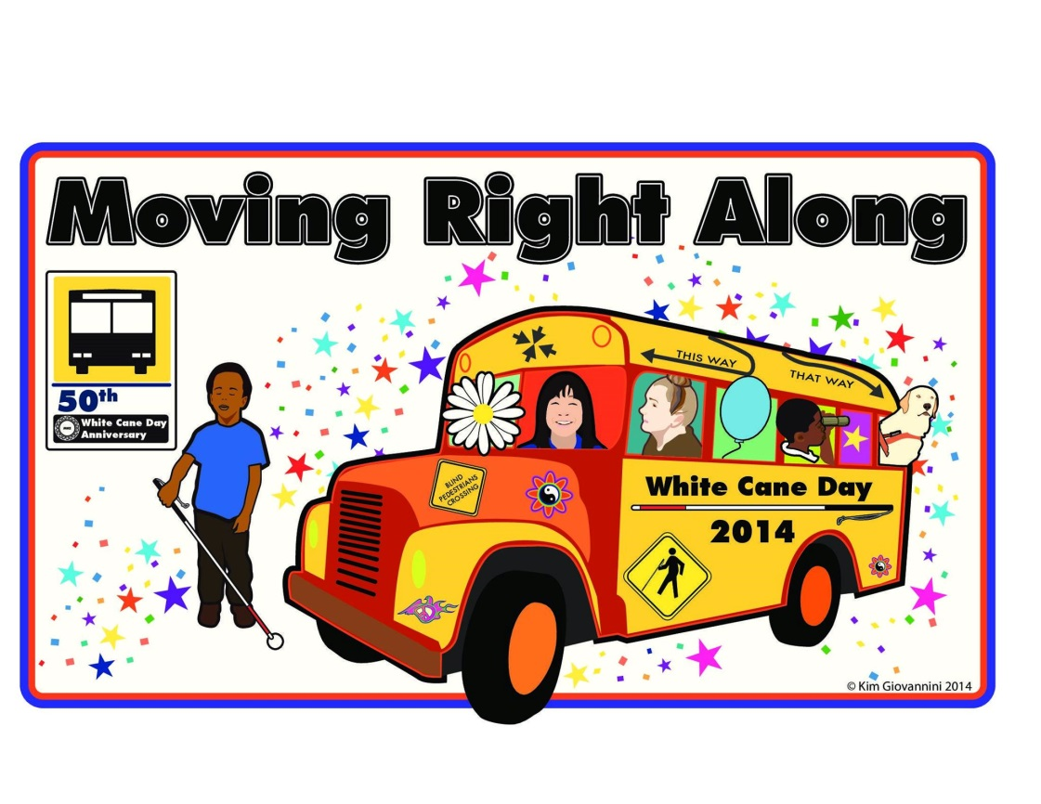

Adding a Magazine Subscription Using BARD

You can add a magazine subscription in BARD in a few easy steps.
- From the BARD main page, you may select an NLS magazine which is currently circulating new issues.
- Search for magazines by title using the drop down menu. You will then see the magazine’s recent issues listed.
- Click on the Subscribe to Magazine Title button. New issues of your subscribed magazine will now be automatically added to your wish list.

If you would like an email notification that the magazine has been added, you may select Email Notification Options. When you are at the Update Account Settings screen, select yes to receive an email alert when new issues of your subscribed magazines are available. Please call WTBBL if you need any assistance with this process.
Pharmacies Offer Talking Prescription Devices for the Visually Impaired

Walgreens is offering its customers the Talking Pill Reminder at its stores nationwide. The device attaches to prescription containers and will be provided for free to pharmacy customers that are blind or have a visual impairment. The Talking Pill Reminder has an audible alarm to remind you when to take your medication. Walgreens also offers large print patient information sheets. Ask your Walgreens pharmacist for more information.

CVS now provides ScripTalk talking prescription labels for prescriptions ordered for home delivery through the online pharmacy. These labels are free
to CVS.com pharmacy customers who are blind or visually impaired. Customers can also request a free ScripTalk reader from Envision America that will allow you to listen to the information on the ScripTalk label. Contact your CVS pharmacist for more information.
We Want to Hear from You

The end of summer is a good time to review your WTBBL account. Are you getting the books you want to read? Are you getting enough books? Too many? Is your machine not holding a charge? Would you like to update your reading preferences, add some favorite authors or series? Let us know if you would like to make any changes to your account. We are happy to help make your listening experiences more pleasurable.

If your cassette or digital player breaks, let us know before you mail it back to WTBBL. If we can, we will send a replacement in the mail the next day, so there will be minimal disruption to your service.

Moving soon? Please give us your new address as soon as possible. If you are moving out of Wisconsin, we can transfer your library records to the talking book library in the state you are moving to.

National Braille Press

The guiding purposes of National Braille Press are to promote the literacy of blind children through braille and to provide access to information that empowers blind people to actively engage in work, family, and community affairs.

Check out their bookstore at www.nbp.org/ic/nbp/publications

Some helpful technology books include:

Getting Started with the iPhone and iOS7: An Introduction for Blind Users

Get the Picture! Viewing the World with the iPhone Camera

Internet Explorer 9 with Jaws, Window-Eyes, and System Access

iOS Success: Making the iPad Accessible

Tweeting Blind

iOS7 Reference Card for iPhone, iPad and iPod Touch

Send: The Essential Guide to Email for Office and Home

Prices are available on the website for National Braille Press.

Order Form Format Changes Again

Beginning with the September–October 2014 issues, the order forms for Braille Book Review and Talking Book Topics will return to listing books in the same order as the titles appear in the publications. The order forms will also include subject category headings to assist with navigation. Patron demand for this reversion has far exceeded the requests that prompted the original change to numerical order in the May–June 2014 issues.
Holiday Closings Reminder!
Please call us at least a week ahead of a closing so you will have books to read. Even if WTBBL is open, some days the
Postal Service is on holiday. We can increase the number of books you receive for the holidays and update your author, series, or subject preferences to make sure you are receiving entertaining and exciting books.

October 13, 2014
Post Office Closed (Columbus Day)

November 11, 2014
Post Office Closed (Veterans Day)

November 27 & 28, 2014
Library Closed (Thanksgiving)

December 24 & 25, 2014
Library Closed (Christmas Eve and Christmas Day)

December 31, 2014 & January 1, 2015
Library Closed (New Year’s Eve and New Year’s Day)
Wisconsin Talking Book and  Braille Library  813 W. Wells St.  Milwaukee, WI 53233-1436 |  | FREE MATTER FOR THE BLIND OR HANDICAPPED
BULLETIN BOARD is available in large print, braille and audio editions, and is also available electronically via email and through NFB-NEWSLINE®, a newspaper by phone service.

Wisconsin Talking Book and Braille Library (WTBBL)
813 W. Wells Street
Milwaukee, WI 53233-1436

1-800-242-8822 (in Wisconsin)
1-414-286-3102 (FAX)
wtbbl@milwaukee.gov (email)
talkingbooks.wi.gov

