Hexagon Tool for Choosing a
Social and Emotional Learning Assessment

Once you have identified the appropriate type of social and emotional learning (SEL) assessment, choosing the best one from the many options available requires careful consideration. The Hexagon Tool for Choosing a SEL Assessment is adapted from the National Implementation Research Network, “The Hexagon: An Exploration Tool” and is meant to help you determine which specific assessment to use. It is recommended that you identify two or more assessment tools to review using this Hexagon Tool worksheet. For assessment choices please consult the CASEL Assessment Catalog, the RAND Education Assessment Finder, and the Wisconsin Developmental Tracker.
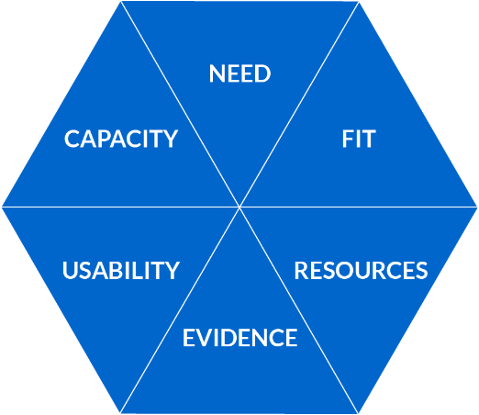
Need
- Will this tool assess the SEL skill(s) gaps you have identified?
- Is this assessment tool strength based rather than diagnostic?

☐ Strongly Meets Need 2 Points
☐ Somewhat Meets Need 1 Point
☐ Does Not Meet Need 0 Points

Fit
- Does the tool align with your chosen SEL framework?
- Does the tool support your definition of SEL?
- Is the tool culturally and ethnically appropriate for your population?
- Does the use of this assessment tool align with other school/district assessments and/or initiatives?
- Does the use of this assessment tool align with school/district priorities?
- Will this assessment tool provide the information required to meet your assessment goal(s)?

☐ Strong Fit 2 Points
☐ Somewhat Fits 1 Point
☐ Does Not Fit 0 Points

Resources
- Do you have the financial capacity to implement this assessment tool?
- Does the assessment tool publisher provide technical assistance for implementation and analysis?
- Does the tool publisher provide training in the use of the assessment tool?
- Do you have local expertise to support the implementation of this assessment tool?
- Do you have local expertise to make meaning of the data obtained?
- Do you have an existing data system to manage the data you obtain from this assessment?

☐ Well Resourced 2 Points
☐ Somewhat Resourced 1 Point
☐ Not Resourced 0 Points

Evidence
- Does this tool meet your required level of rigor?
- Does the assessment tool demonstrate evidence of effectiveness, validity, and reliability (i.e., either peer reviewed or practice-based evidence)?

☐ Strongly Meets Evidence Requirement 2 Points
☐ Somewhat Meets Evidence Requirement 1 Point
☐ Does Not Meet Evidence Requirement 0 Points

Usability
- Is the assessment tool easy to understand and easy to use?
- Is the method of implementation doable in your current system and structure?
- Is the data that will be provided useable for your stated assessment goal(s)?
- Does this assessment tool provide options for multiple respondents or assessment of multiple environments?

☐ Highly Usable 1 Point
☐ Somewhat Usable 2 Points
☐ Not Usable 0 Points

Capacity
- Do you have the staff to effectively implement this assessment tool?
- If the tool requires training for use, do you have time to provide it?
- If the tool does not provide analysis, do you have time to allow for analysis of the data to address your goal(s)/purpose(s)?
- Do you have the time and ability to create communication about the data to stakeholders?
- Are the time requirements of this assessment tool doable by the staff who will be responsible?
- Do you have the resources to manage the data?
- Does the benefit of this assessment outweigh the time required to implement this assessment tool?

☐ Strong Capacity 2 Points
☐ Some Capacity 1 Point
☐ No Capacity 0 Points

Hexagon Tool Score Sheet
For each assessment tool, enter the score from the worksheet above for the six domains of the Hexagon Tool.

Evidence-Based Program Name | Assessment Tool Name Example
 | Program  Point Score Example | Program 1  Point Score | Program 2  Point Score | Program 2  Point Score
Need | 2
Fit | 2
Resources/Supports | 1
Evidence | 0
Usability | 2
Capacity | 1
Total Score | 8

