Why Do Animals Live Where They Do?
A 3rd Grade NGSS/WSS Science Lesson Series
Interdisciplinary Standards
Common Core State Standards for ELA/Literacy and Next Generation Science Standards: Convergences and Discrepancies Using Argument as an Example by Okhee Lee
Background Knowledge
Lesson Description
Resources
Learning Targets
Scoring Rubric
Claim Reasoning Graphic Organizer
Writing Conference Plan
Book List
Websites
Benchmark Papers
Sample Paper 1 (Score 1)
Sample Paper 2 (Score 2)
Sample Paper 3 (Score 3)
Sample Paper 4 (Score 4)

Interdisciplinary Standards
Science Standards: How does this lesson support 3-dimensional learning? The following note explains what students will know and be able to do in this lesson. The practices are in blue, the disciplinary core ideas are in orange, and the cross-cutting concepts are in green.

In this lesson students will understand and argue with evidence that climate conditions cause animals to need physical adaptations or behave in a way that promotes survival. Students will explore how authors of informative texts build arguments using cause and effect structures.

Students will also collect, organize in graphs, and compare typical weather patterns in different regions of the world in order to understand why it is that animals survive well in some locations and less well (or not at all) in others.

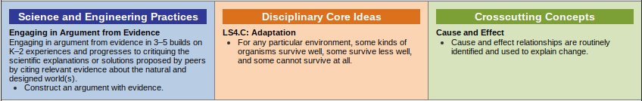
- Construct an argument with evidence that in a particular habitat some organisms can survive well, some survive less well, and some cannot survive at all. (3-LS4-3)
- Represent data in tables and graphical displays to describe typical weather conditions expected during a particular season. (3-ESS2-1)
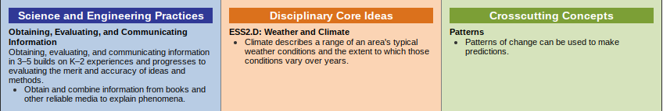
- Obtain and combine information to describe climates in different regions of the world. (3-ESS2-2)
- CCSS ELA Standards -
  - Describe the relationship between a series of historical events, scientific ideas or concepts, or steps in technical procedures in a text, using language that pertains to time, sequence, and cause/effect. (RI 3.3)
  - By the end of the year, read and comprehend informational texts, including history/social studies, science, and technical texts, at the high end of the grades 2-3 text complexity band independently and proficiently. (RI 3.10)
  - Write opinion pieces on topics or texts, supporting a point of view with reasons. (W 3.1 a-d)

Common Core State Standards for ELA/Literacy and Next Generation Science Standards: Convergences and Discrepancies Using Argument as an Example by Okhee Lee

Background Knowledge

Animals are often adapted to a particular environment. The behaviors and physical characteristics of an animal may make that animal better suited to a particular environment. An example of a physical characteristic is the fur of a polar bear which supports its survival in very cold weather. An example of a behavior is that by moving slowly a sloth can survive on an herbivorous diet and go undetected by predators in the rainforest. For more information, see this article from the American Geosciences Institute: https://www.americangeosciences.org/education/k5geosource/content/fossils/how-are-living-things-adapted-to-their-environments
A climate is the typical weather pattern in a geographic region over a long period of time. Climate data can be graphed using average temperature and precipitation data for a specific region.
Through using claim, reasoning, and evidence students will argue that a specific animal is adapted to a particular climate or environment and would not survive as well or at all in another climate or environment. Students will need time to make sense of new information through conversations around weather, maps, and animal behaviors and physical characteristics. As you work through this unit, make time for students to have conversations about these new ideas in pairs, small groups, and as a whole class.

Lesson Description
- Engage:
  - Switchzoo Habitat Game - Student explore climate conditions preferred by specific animals.
  - After the each round, ask students to talk with a partner about what they notice. As you continue consider posing questions such as: Is this game realistic? Are animals only able to live in specific conditions? Are there other factors that promote or limit animal survival?
- Explore:
  - Climate and typical weather conditions
    - At the beginning of the year start collecting data on daily temperature and precipitation for a local area and two other locations in different climate zones.
    - Find the average temperature and precipitation for each month in each climate zone.
    - Use Plotly.com to create a graph of the weather data (line plot for temperature and bar graph for precipitation.
    - If you did not collect data or if you are having trouble with Plotly.com you can use the website en.climate-data.org to collect climate data or climate graphs for major city locations.
    - Students compare weather pattern data from different locations and analyze the differences.
      - Students can do this in triads. Each group should have a set of weather pattern data and a map showing the locations of the plotted cities. Ask student groups to notice differences or similarities in the weather patterns of different locations.
  - Use books to explore animal physical characteristic (adaptations) and behaviors that help them to survive. (See book list below for ideas.)
    - Ask questions such as
      - “Why do these animals need to live where they do?”
      - “What adaptations help them survive in their environment?”
      - “What if the climate changed or they moved to a different place?”
  - Use a second reading of books to explore how an author structures cause-effect ideas within a science text. Collect examples of cause and effect sentence structure from these books to use later as examples of how students can structure their own arguments.
- Explain:
  - Students choose an animal to investigate. Students collect information about the animal’s physical characteristics and typical behaviors (ex: nocturnal, hunt in packs, live underground, etc.) *See included book list for possible titles.
  - Students collect and graph climate data (en.climate-data.org) for the region the study animal lives in. Students also read about the climate to learn about how patterns of temperature and precipitation lead to physical characteristics of that habitat.
- Elaborate:
  - Students will begin to synthesize their data on the climate an animal lives in with the specific physical characteristics and behavior of that animal.
  - Model cause-effect writing from the book study in the explore section. Refer back to examples of ways that authors have explained the relationship between animals and their habitat.
  - The teacher models the use of the Claim-Reason Graphic Organizer (attached below) to draw specific connections between particular animal physical characteristics or behaviors to particular climate characteristics. Then students use the organizer on their own to make connections between their chosen animal and its habitat.
    - The teacher should also consider the Scoring Rubric at this stage. The Scoring Rubric describes what students should be able to explain in their writing.
    - The teacher may also share or review the Learning Targets. These describe what students should be able write about.
  - Students use the Claim-Reasoning Graphic Organizer to write an argument that an animal is adapted for a particular habitat and would not do as well (or not survive at all) in another habitat. This is the performance task.
  - Students add a map of the region that the animal lives in and draws a connection between weather patterns in that region of the world and
  - Play the Switchzoo game again
    - Repose the questions: Is this game realistic? Are animals only able to live in specific conditions? Are there other factors that promote or limit animal survival?
    - Ask students to consider what conditions might be necessary in this game if the students’ animals were included.

- Evaluate:
  - Use the scoring rubric to evaluate students’ written claim.
  - Use the Science Writing Conference Plan to reflect on student’s work with them.

Resources

Learning Targets

An Animal in its Environment Project
Learning Targets

Science

- I can engage in an argument using evidence.

- I demonstrate understanding that for any particular environment, some kinds of organisms survive well, some survive less well, and some cannot survive at all.

- I can identify and use cause and effect relationships to explain my reasoning.

Writing

- I can introduce the topic I'm writing about and state my opinion/point of view.

- I can support my opinion with reasons.

- I can state my reasons in an organized way. (cause and effect structure)

- I can use linking words and phrases (eg. because, therefore, since, for example) to connect opinion and reasons.

- I can provide a concluding statement or section.

Reading Informational Text

- I can describe the connection between a series of scientific ideas or concepts using time, sequence, and cause and effect language.

- I can read and comprehend complex informational texts including science.

Scoring Rubric
The following rubric explains what students will be able to write about. Evidence of the practices are in blue, the disciplinary core ideas are in orange, and the cross-cutting concepts are in green.

 | 4 | 3-Proficient | 2 | 1
Claim  Science and Engineering Practices:  - I can engage in an argument using evidence  Opinion Writing:  - I can introduce the topic I'm writing about and state my opinion/point of view |  | - Student makes a claim about why an animal survives in one ecosystem better than another. | - Student makes a claim about why an animal survives in one ecosystem but needs to make a connection between the behavior/physical characteristic and climate. | - Student can write about an animal and/or an ecosystem.
Reasoning  Crosscutting Concepts:  - I can identify and use cause and effect relationships to explain my reasoning  Reading Informational Text  - I can describe the connection between a series of scientific ideas or concepts using time, sequence, and cause and effect language. (RI 3.3)  Opinion Writing:  - I can support my opinion with reasons.  - I can state my reasons in an organized way. (cause and effect structure)  - I can use linking words and phrases (eg. because, therefore, since, for example) to connect opinion and reasons. |  | - Student provides scientific evidence to support the claim. This includes climate graph and other characteristics of the animal and its environment. | - Student needs to include more important scientific evidence to support the claim such as a climate graph or other characteristics linking the animal to its environment | - Student provides little to no scientific evidence to support the claim.
Evidence  Science and Engineering Practices:  - I can engage in an argument using evidence |  | - Student identifies a causal relationship between the environment and the animal’s needs. (cause/effect) | - Student provides a weak causal relationship between the environment and the animal’s needs. (cause/effect) | - Student provides no causal relationship between the environment and the animal’s needs.
Conclusion  Opinion Writing:  - I can provide a concluding statement or section. | - Student provides a concluding statement or section that summarizes the claim and leaves the reader with a sense of closure in a way the is unique, natural, and convincing. | - Student provides a concluding statement or section that summarizes the claim and leaves the reader with a sense of closure | - Student provides a concluding statement or section that does not either summarizes the claim or leaves the reader with a sense of closure. | - Student ends piece with no evidence of a clear conclusion.
Content  Disciplinary Core Ideas:  - I demonstrate understanding that for any particular environment, some kinds of organisms survive well, some survive less well, and some cannot survive at all.  Reading Informational Text  - I can read and comprehend complex informational texts including science. (RI 3.10) | - Student reads and comprehends informational text and demonstrates understanding of science content.  - Student demonstrates that this concept applies generally to other animals. (CCC: Patterns) | - Student reads and comprehends informational text and demonstrates understanding of science content. | - Student reads and comprehends informational text and demonstrates understanding of science content with misconceptions. | - Student reads informational text but does not demonstrate understanding of science content or cannot read informational text.

Claim Reasoning Graphic Organizer
Animal physical characteristic or behavior

Characteristics of climate

Animal physical characteristic or behavior

Characteristics of climate

Writing Conference Plan
Date:_______________ Student:_______________________

Science Writing Conference Plan

Shared Reading
- Initiate the conference
- General check

Compliment
- Have student reflect
  - What do you think you did well and what can you improve?
- Name something the student can do and something that the should keep doing

Teaching Point
- Identify for the student one thing you want them to continue to work on
- Explicitly state how to use the strategy or skill to work on

Model
- Use student’s work to model revision

Generalize Teaching Point
- Restate teaching point with next paper in mind

Book List
Books on animal adaptations:
- Living Color by Steve Jenkins
- How to Swallow a Pig by Steve Jenkins and Robin Page
- How Many Ways Can You Catch a Fly by Steve Jenkins
- Survival at 40 Below by Debbie S. Miller
- Flashy Fantastic Rain Forest Frogs by Dorothy Hinshaw Patent
- Polar Bears by Mark Newman
- Family Pack by Sandra Markle

Websites
- https://en.climate-data.org/ (climate data)
- http://kids.nationalgeographic.com/animals/ (animal information)
- https://plot.ly/ (data graphing)

Benchmark Papers

Sample Paper 1 (Score 1)
date:5/19/17
since
Barn owl and facts

A barn owl needs to live in a barn to service. The barn owl needs to live in warm places.
A barn owl body is not made for a cold dessert because it is made for barns it needs fish.
In Figure A you see where the barn owl lives .in figure B The red stands for temperature and the blue stands for precipitation.
Barn owls are not extinct .

Figure A
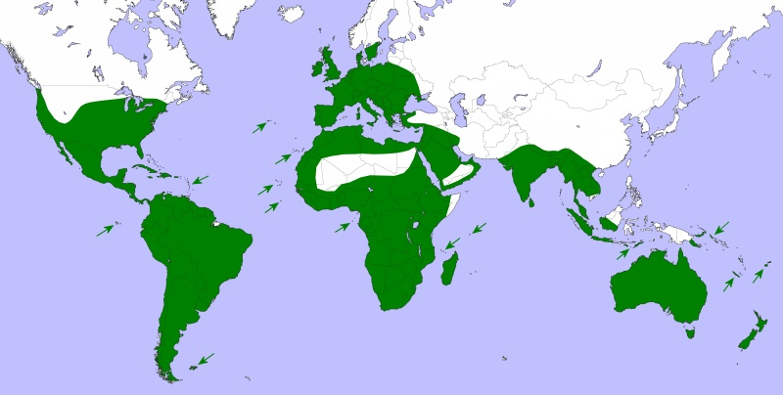

Figure B

Houston, Texas

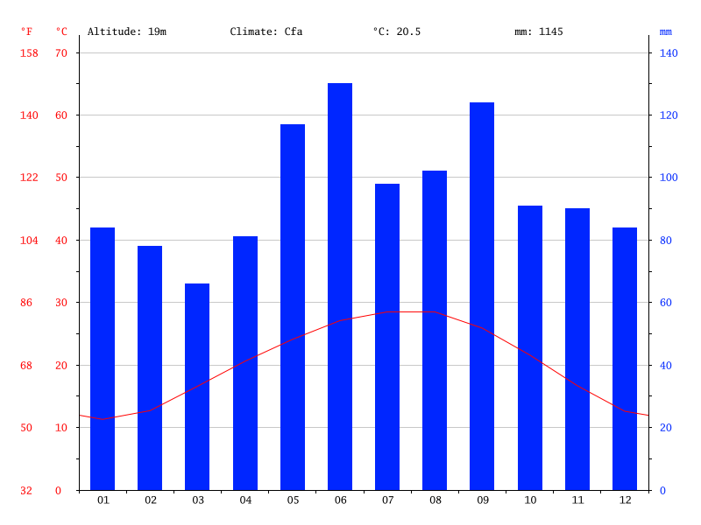

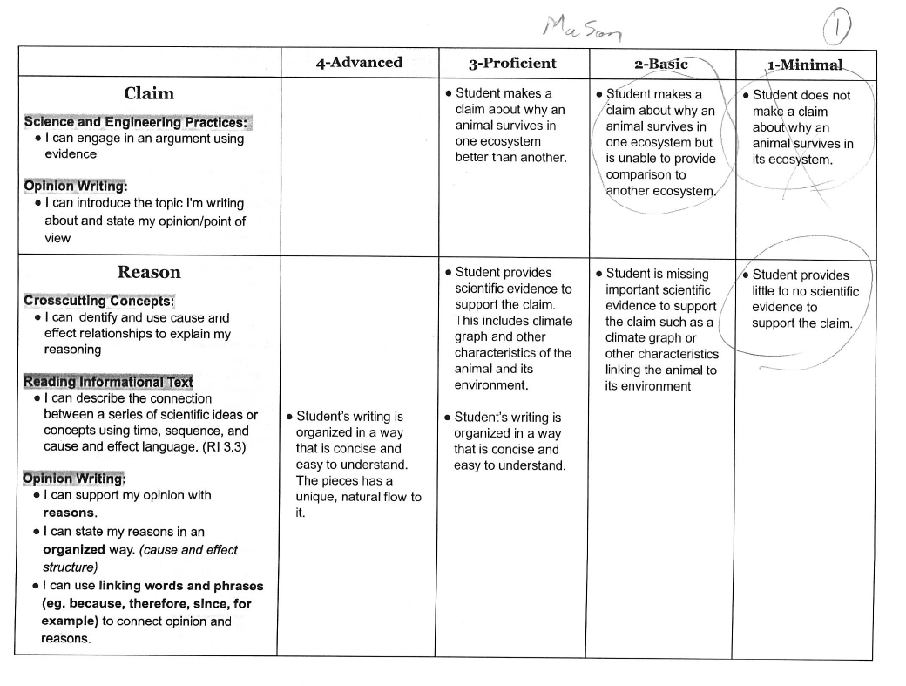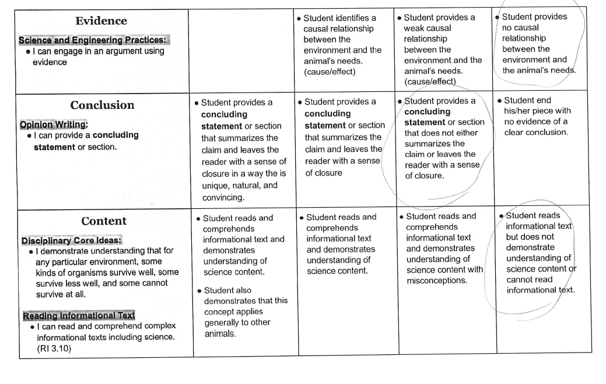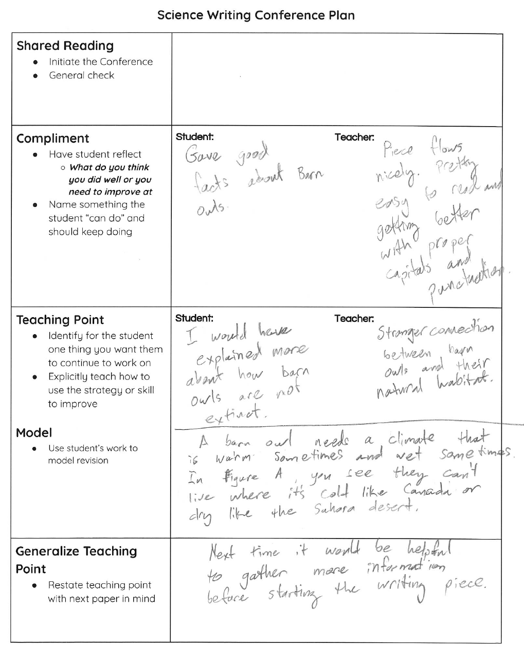

Sample Paper 2 (Score 2)
Animal in its Environment:Bearded Dragon
May 9 2017

The bearded dragon in the far south

The bearded dragon is a reptile that can live in extremely humid and hot areas in and near
Australia's northern territories. It can live in temperatures over 60 degrees fahrenheit all day every day.

It can not live in the polar regions because it can not find food that it can eat and would be eaten ALIVE by polar bears or snow foxes. It’s skin will not protect it from the cold because it is thin and doesn't have fur. In Figure A the climate data shows that the temperatures never get below 60 degrees fahrenheit all year long and is a lot hotter than Wisconsin's winters and colder summers unlike Wisconsin’s summers.

In figure B it shows the map of where the bearded dragon lives and does not live.

The bearded dragon is a very special reptiel for many reasons, 1 because it lives in a fairly small country and are
Living pretty well in the wild and will survive for years to come.

Brisbane, Australia

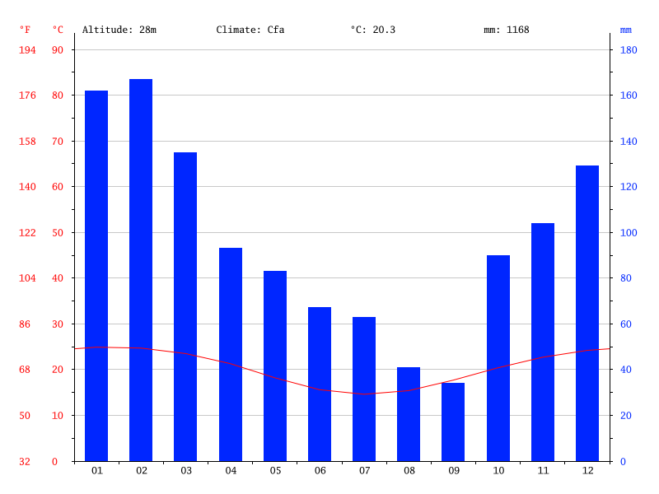

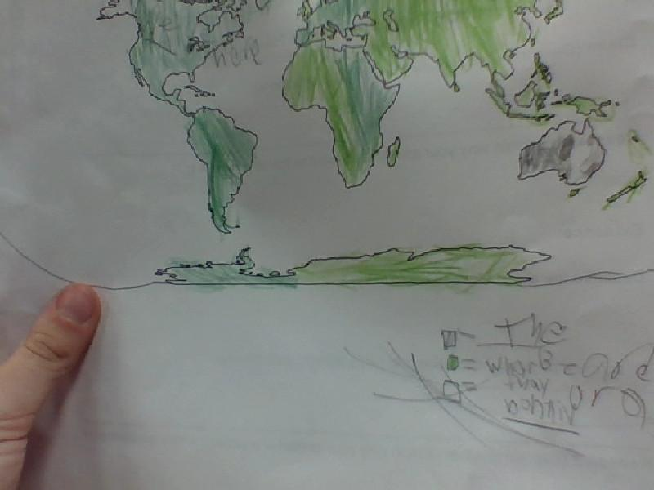

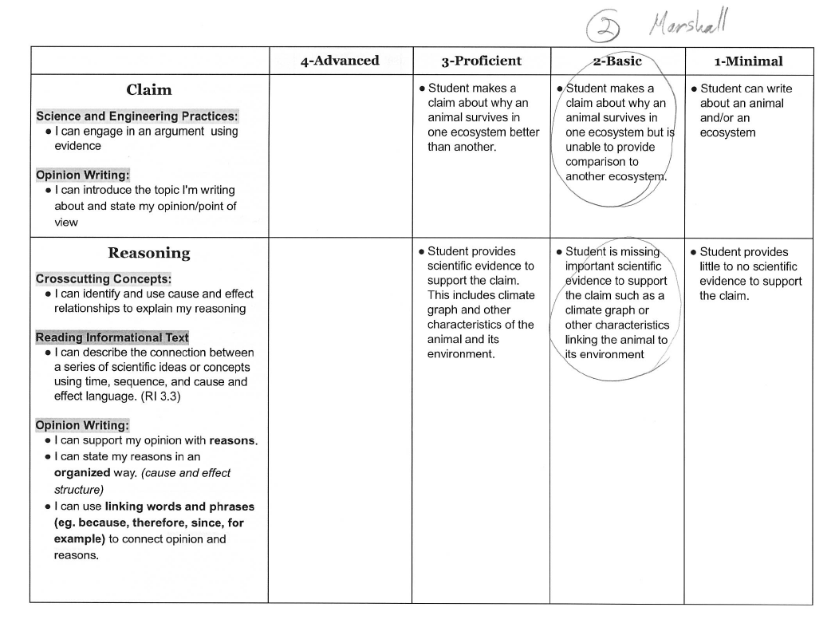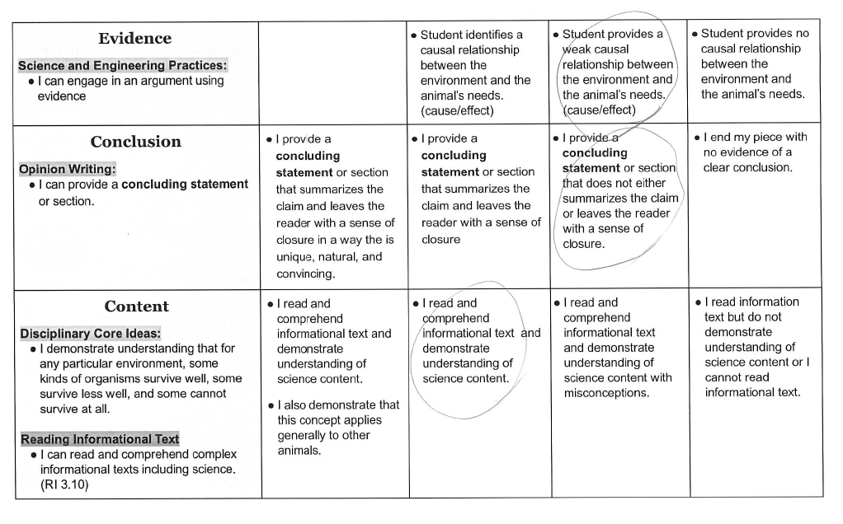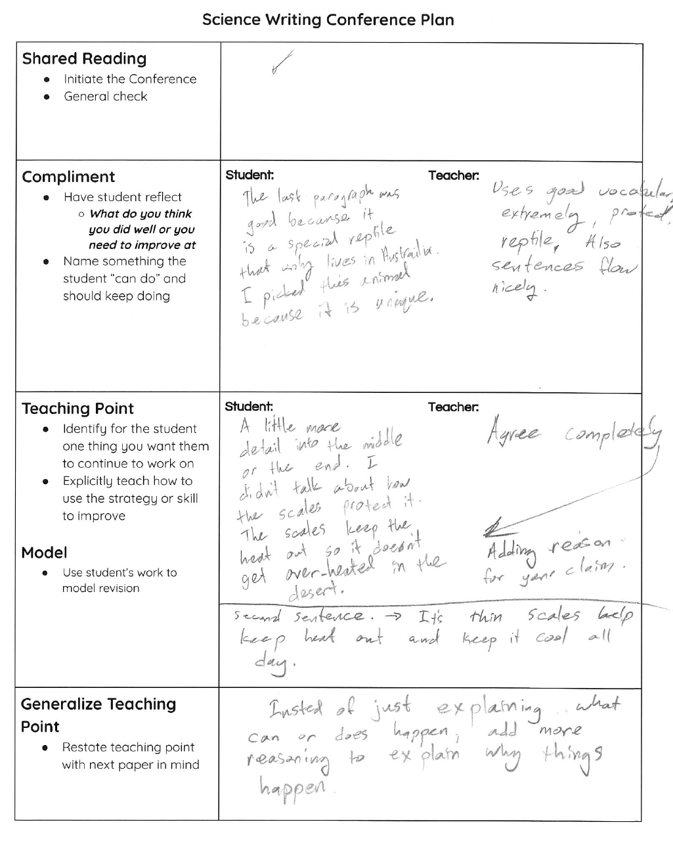

Sample Paper 3 (Score 3)
Animal In its Environment: Great Giant Panda
May 9, 2017

Perfect Pandas In the Forest

A Great Giant Panda needs to live in a forest. Particularly needs to live in a Bamboo forest. It has teeth good for gnawing and crunching on bamboo. A panda uses good smell to find a good place to eat. Also to attract mates. Pandas need to live in a bamboo forest because it helps them survive in a habitat. It is made of their food so they never have to go out hunting and risk their life more than it already is risked. And because they can easily blend in with the green bamboo because they can hide at the bottom of the bamboo where no animals check. It gets a lot of snow to blend in with white snow for survival.
A panda would not do very well in a cold environment because the pandas sense of smell would have to adapt to the cold environment and it wouldn’t be able to find what it needs to survive in a cold climate. Also a panda would not do good in a cold environment because it wouldn’t be able to find a home that is a relative to a bamboo forest and there aren’t any big forests just in general but it would be spectacular for a panda to discover a bamboo forest if there aren’t many forests in the arctic.
In Figure A, the map shows where pandas live in China. Figure B shows the temperature for Ganzhou, China and the precipitation for Ganzhou, China the temperatures are tremendously hot they don’t really get above 86 degrees fahrenheit on a basis but a couple of days got over 100 degrees fahrenheit. It never really gets lower than 40 degrees fahrenheit. Ganzhou, China also gets a humongous amount of precipitation
As it is, pandas need to be in their normal environment or they could not survive and be here with us today. Pandas are getting extinct by people who are cutting down bamboo shoots in bamboo forests I hope people will stop cutting down bamboo forests for the lives of perfect pandas in the forest.

Figure A
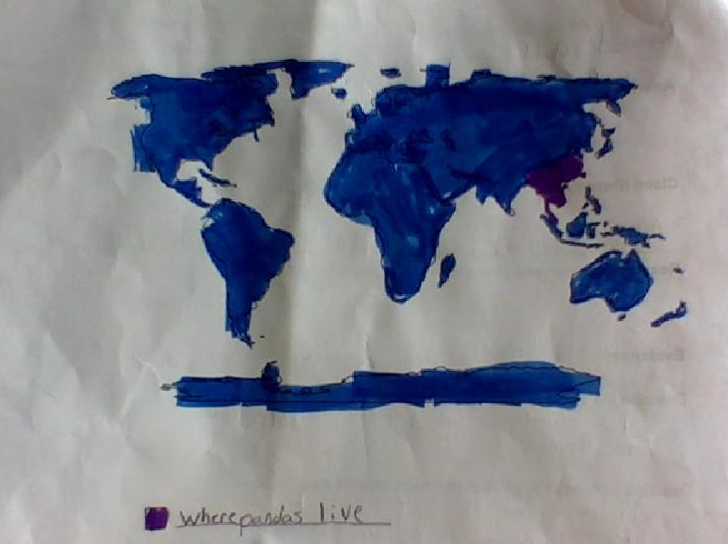

Figure B
Ganzhou, China Climate Data

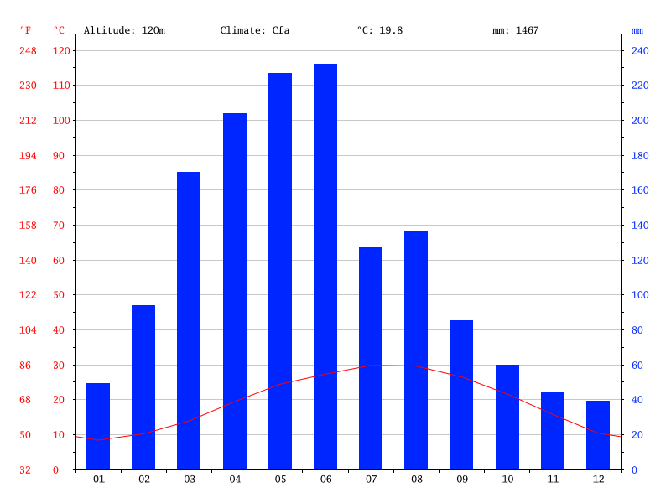

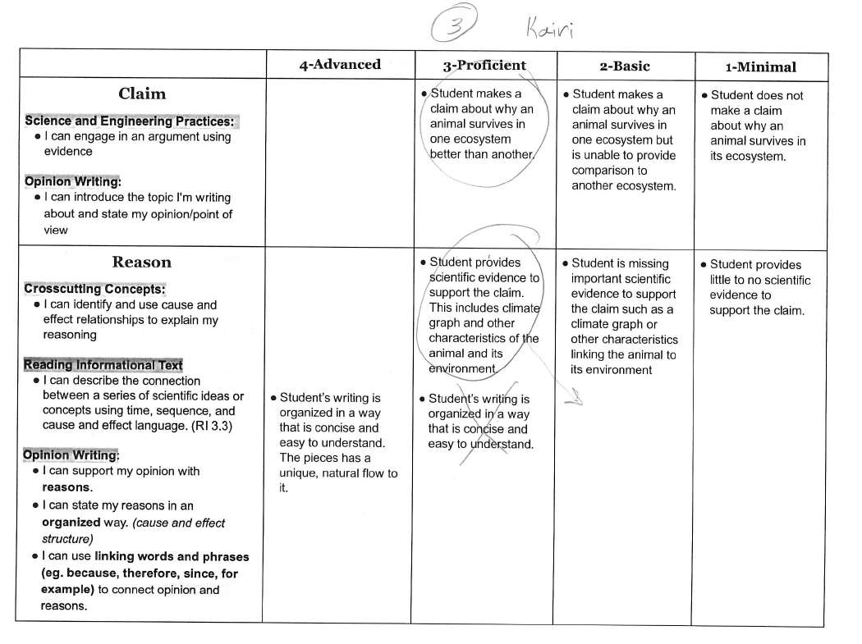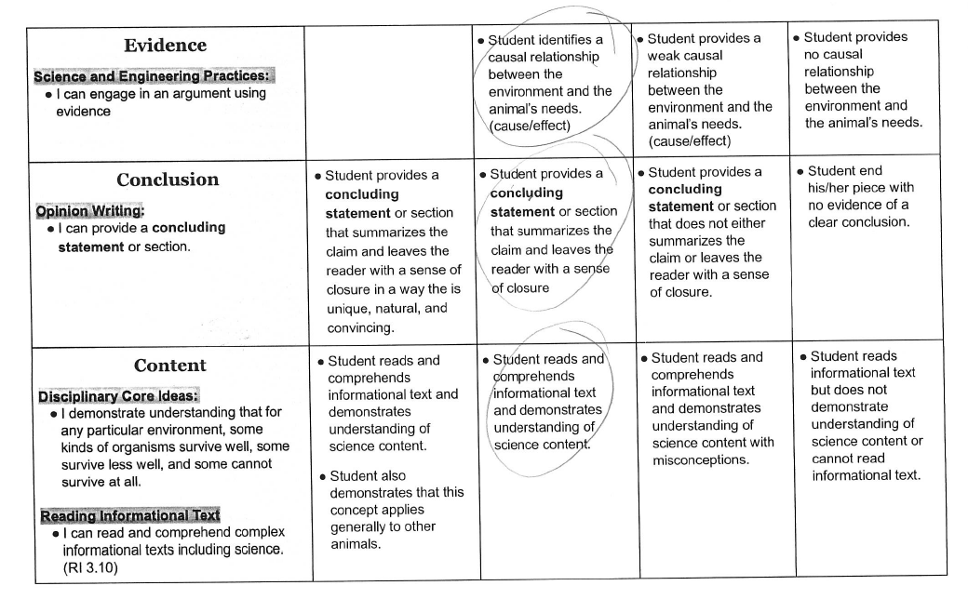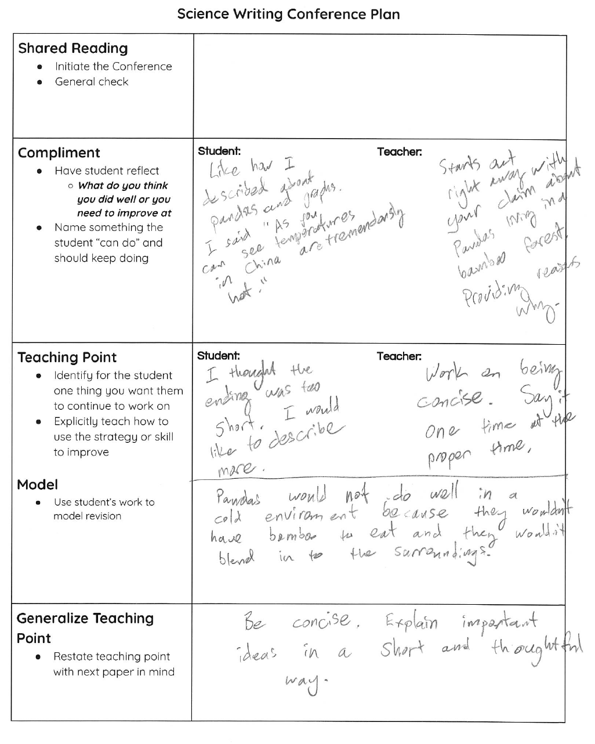

Sample Paper 4 (Score 4)
Animal in its Environment: Great Horned Owl
May 9, 2017

Great Horned Owls in the Trees

Great horned owls have to live in a climate with lots of trees for camouflage. Their ear tufts help them hide in the trees because the ear tufts look like short branches. Their brown, gray and cream colored feathers also help them blend in with the trees while they sleep.
A great horned owl would not survive well in the arctic because there aren’t any trees to blend in with and the brown, gray and cream colored feathers would stick out against the white snow. And great horned owls will not be able to survive the cold either because they would only have a thin layer of feathers to keep warm. But the feathers would not keep the owl very warm so it would eventually die from the cold.
In Figure A, the map shows that great horned owls live in the southern part of North America and Madison, Wisconsin. Figure B, shows that the temperature is warm enough from March until December for trees to grow, and Madison Wisconsin has enough precipitation for trees to grow so great horned owls live well there.
As you can see that if great horned owls did not have any trees to hide in then their predators would eventually find all the great horned owls and eat them then they would get endangered and soon get extinct. If they get extinct then all the other animals that eat great horned owls would die and go extinct and so on. If there weren’t any trees in the world almost all the animals in the world would go extinct or would grow in numbers.

Figure A
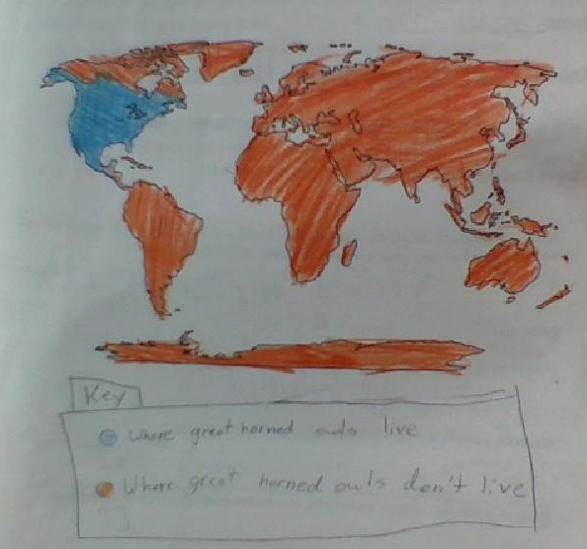

Figure B
Madison, Wisconsin

