6-8 Performance Task Work - Life Science

Description of Activity

Phenomenon
Organisms can be categorized into types, such as producers, consumers, and decomposers based on their behaviors and role in an ecosystem. An organism’s appearance is often an indication of its behavior and therefore also an indication of its type. For example, an organism with claws and teeth is likely a consumer and a green organism is likely a producer with noticeable chloroplasts. The features that help identify types of organisms at the macroscopic scale can also be used to identify types of organisms at the microscopic scale.

Scenario
For this activity students will draw and describe three microscopic organisms. The drawing and description of each organism will be used as evidence to argue its type; consumer, producer, or decomposer.

Student needs
Students will need a supply of water from a swampy area, basic skills with a microscope, and prior knowledge of organism types. It may be helpful if students had access to the internet so they can research descriptions and images of the types of organisms. They will also need a worksheet, such as the one following, so they can draw and describe their organisms and respond to questions.

Standards Addressed

MS-LS2-2 Ecosystems: Interactions: energy, and dynamics - 3.2.2 Organism interactions
Construct an explanation that predicts patterns of interactions among organisms across multiple ecosystems. Emphasis is on predicting consistent patterns of interactions in different ecosystems in terms of the relationships among and between organisms and abiotic components of ecosystems. Examples of types of interactions could include competitive, predatory, and mutually beneficial.

Crosscutting Concepts - Structure and function.
The way in which an object or living thing is shaped and its substructure determine many of its properties and functions.

Science and Engineering Practices - Engaging in argument from evidence
In science, reasoning and argument are essential for identifying the strengths and weaknesses of a line of reasoning and for finding the best explanation for a natural phenomenon. Scientists must defend their explanations, formulate evidence based on a solid foundation of data, examine their own understanding in light of the evidence and comments offered by others, and collaborate with peers in searching for the best explanation for the phenomenon being investigated.

Focus of Assessment

MS-LS2-2 Ecosystems: Interactions: energy, and dynamics - 3.2.2 Organism interactions
The student connects a specific observation of an organism to its role in the ecosystem. Focus should be on the organism's interaction with living or nonliving parts of the ecosystem and not the organism’s appearance. Note; a student may accomplish this without correctly identifying the organism. For example a Venus Flytrap interacts with a fly in a way that makes it appear as a consumer even though it may be better classified as a producer.

Crosscutting Concepts - Structure and function.
The student connects a specific observation of an organism to its role in the ecosystem. Focus should be on the organism's appearance and not how it interacts with the ecosystem. Note; a student may accomplish this without correctly identifying the organism. For example, a student may identify a stick bug as a producer because it has qualities similar to a stick with leaves.

Science and Engineering Practices - Engaging in argument from evidence
The student draws and/or describes an observation of an organism and uses that observation logically to classify the organism. Focus should be on the student’s presentation of evidence and its connection to their argument. For example, a student should not argue the organism is a consumer because it has claws and teeth unless those qualities are drawn and/or described in the observations. Conversely a student should not simply draw the organism with claws and teeth and argue it is a consumer because of “how it looks”. A good connection will explain why the student makes the conclusion they did. For example, a student may point out they concluded their organism was a consumer because it had claws and teeth like more familiar macro sized consumers.

Adaptations

Lesson
Students search for other organism classifications such as predator / prey.
Provide students a digital microscope allowing them to take pictures or video of the organisms they find.
Ask students to find the organisms on land instead of from the water source.
Ask students to present oral arguments in addition to or in place of their worksheet.

Assessment
The lesson would also give insight to other domains that could be assessed: A student’s ability discern which qualities of the organism are significant and communicate those qualities using test and drawings is a skill associated with the Science and Engineering Practice - Obtaining, evaluating, and communicating information.
A student may show evidence they examined an organism at different scales to determine its classification. They could also demonstrate their ability to choose an appropriate magnification to draw their organism, both of which would be evidence towards the Cross Cutting Concept - Scale, proportion, and quantity.

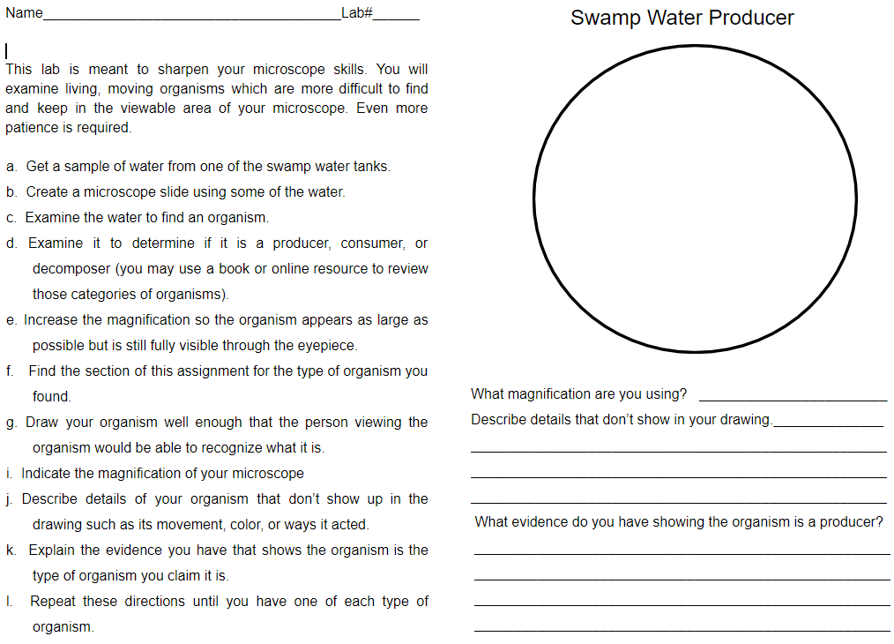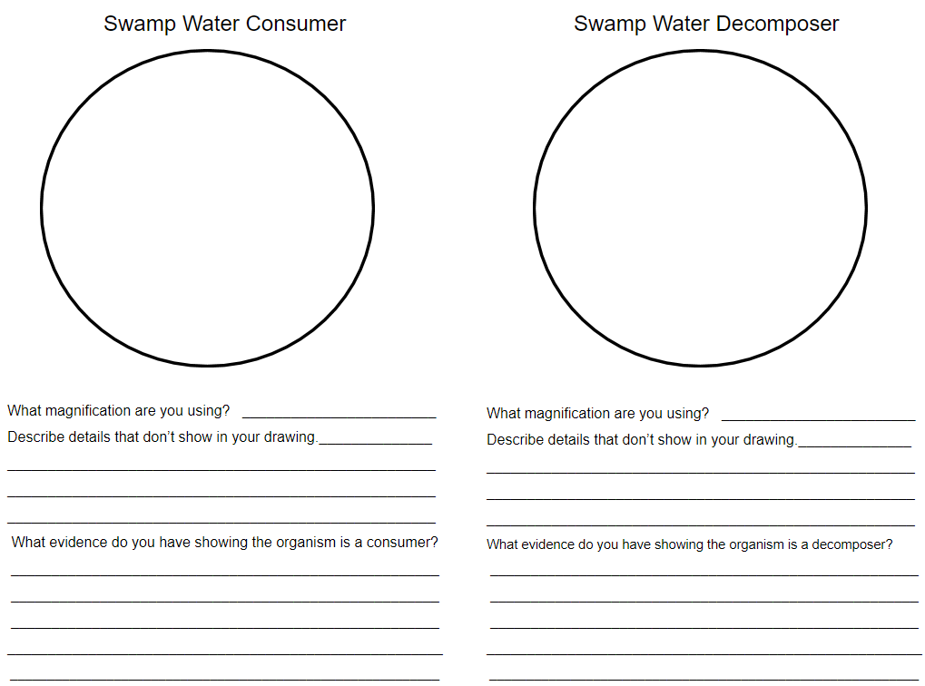
Rubric
MS-LS2-2 Ecosystems: Interactions: energy, and dynamics - 3.2.2 Organism interactions
Construct an explanation that predicts patterns of interactions among organisms across multiple ecosystems. Emphasis is on predicting consistent patterns of interactions in different ecosystems in terms of the relationships among and between organisms and abiotic components of ecosystems. Examples of types of interactions could include competitive, predatory, and mutually beneficial.
Developing | Basic | Proficient | Advanced
Student does not connect the microscopic organism’s types to observations of the organism’s relationships among and between organisms and abiotic components of its ecosystem. | Student uses the organism’s relationships among and between organisms and abiotic components of its ecosystem to support their claim of the organism’s type. | Student accurately identifies three microscopic organism’s types based on an observation of the organism’s relationships among and between organisms and abiotic components of its ecosystem. | Student accurately identifies three microscopic organism’s types based on multiple observations of the organism’s relationships among and between organisms and abiotic components of its ecosystem.
Cross Cutting Concept - Structure and function.
The way in which an object or living thing is shaped and its substructure determine many of its properties and functions.
Developing | Basic | Proficient | Advanced
Student’s response about the type of organism is not supported by observations. | Student identifies a type of organism based on its similarities to familiar organisms but may not identify the specific feature the organism has that identifies its type. | Student arrives at logical conclusions that connect features of the organism to its type and function in an ecosystem. | Student identifies multiple features that connect the organism to its type and function on an ecosystem.
Science and Engineering Practices - Engaging in argument from evidence
In science, reasoning and argument are essential for identifying the strengths and weaknesses of a line of reasoning and for finding the best explanation for a natural phenomenon. Scientists must defend their explanations, formulate evidence based on a solid foundation of data, examine their own understanding in light of the evidence and comments offered by others, and collaborate with peers in searching for the best explanation for the phenomenon being investigated.
Developing | Basic | Proficient | Advanced
Student’s images and descriptions do not support their claims about the type of organism identified. | Student presents evidence to support their claim about the type of organism identified. | Student presents and clearly connects evidence to logical conclusions about the type of organism identified. | Student presents and clearly connects multiple pieces of evidence to logical conclusions about the type of organism identified.
Example 1
When assessing each standard, the evaluator should consider how consistently the student performs on each submission; producer, consumer, and decomposer. A student should be able to perform consistently to be considered proficient. Scores in the example below are based on the single submission.
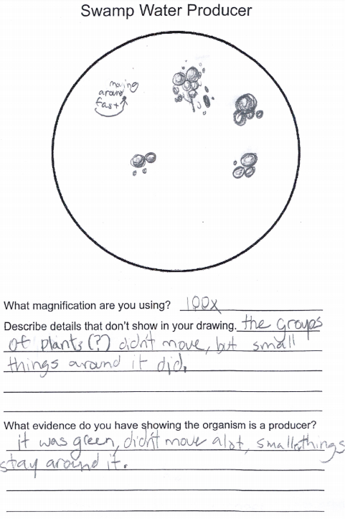
DCI | Proficient
Student correctly relates their microscopic observations to the macroscopic observation that producer, such as a tree, interacts with its ecosystem by providing food and shelter for other organisms.
CCC | Advanced
Student’s classification is based on two physical similarities of the microscopic organism to the macroscopic world; organism is green and doesn’t move.
SEP | Proficient
Student presents multiple observations. They draw and diagram with some detail. However the connection between the evidence and conclusion lacks a clear explanation. The inclusion of “plants (?)” in the description indicates the student is presenting evidence the organism is a plant, and therefore is a producer, but they do not express that thought explicitly. This example received a proficient mark because it presented quality evidence, a logical conclusion, and hinted at the connection between the two. However, the student was given a side comment about the importance of explicitly communicating those connections

Example 2
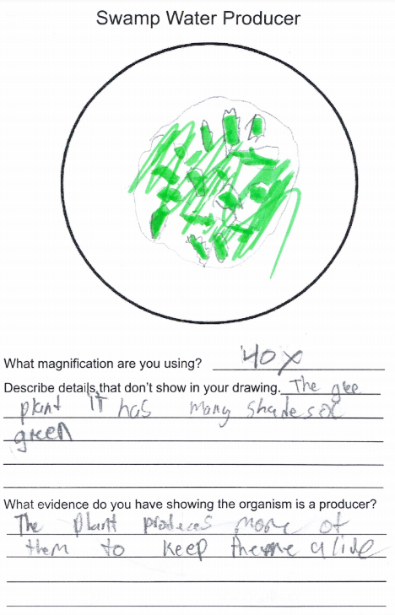
When assessing each standard, the evaluator should consider how consistently the student performs on each submission; producer, consumer, and decomposer. A student should be able to perform consistently to be considered proficient. Scores in the example below are based on the single submission.

DCI | Developing
The response shows an understanding that a plant is a producer but it is not based on an observation of the organism’s interaction with the ecosystem. The response also indicates incorrect understanding. The statement that “The plant produces more of them...” indicates the student bases their description on the name ‘producer’ and assumes it means producing more of itself rather than producing food for the ecosystem.
CCC | Basic
The student identifies the color green as a similarity to other producers but does not identify a specific feature of the organism that connects it to its function. It shows the student groups the organisms based on appearance rather than what it does.
SEP | Basic
The student presents the organism’s color as evidence but does not use that to support their conclusion. Their conclusion seems to be based on the observation that the “plant was producing more of them” but it is unclear, and unlikely, the student made that observation.

Example 3
When assessing each standard, the evaluator should consider how consistently the student performs on each submission; producer, consumer, and decomposer. A student should be able to perform consistently to be considered proficient. Scores in the example below are based on the single submission.
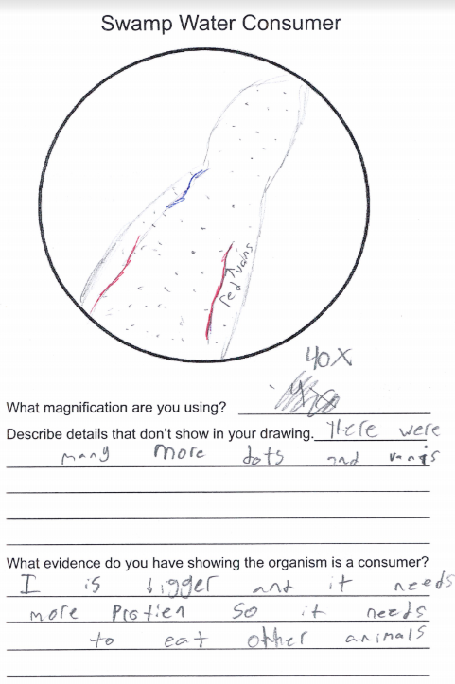
DCI | Basic
The student indicates understanding that eating other animals indicates it is a consumer but that conclusion is based on a false assumption that a consumer’s size indicates its type rather than an observation of the organism interacting with its ecosystem. Likely the student is conflating the predator/prey relationship. The student could not use their logic to “predict consistent patterns of interactions in different ecosystems” as stated in the standard. This example demonstrates understanding of what a consumer does and a misunderstanding of how to recognize that quality. Since it shows some understanding, greater weight would be placed on other examples the student submits.
CCC | Proficient
The student accurately identified an organism and bases its type on a feature of the organism (“bigger and needs more protein”).
SEP | Proficient
Student describes their (flawed) logic fully by relating size to the need for protein, to eating other organisms, to being a consumer.

Example 4
When assessing each standard, the evaluator should consider how consistently the student performs on each submission; producer, consumer, and decomposer. A student should be able to perform consistently to be considered proficient. Scores in the example below are based on the single submission.
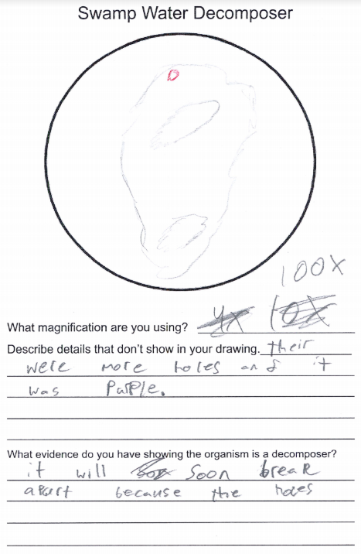
DCI | Basic
Student demonstrates some understanding of how a decomposer interacts with the ecosystem because they identify the effect of breaking biotic material into smaller parts. They demonstrate a lack of understanding of the cause and effect of that interaction at a microscopic level because they identify what has been decomposed rather than what is decomposing.
CCC | Basic
Student has an obvious misconception that a decomposer is itself decomposing rather than making the connection that small organisms, called decomposers, are causing the decomposition they are observing. Their view is centered on the organism rather than looking for evidence of how the organism interacts with the ecosystem.
SEP | Basic
The student provides some evidence (holes in the organism) to support what they misconceive a decomposer to be. However they fail to give evidence why they believe the organism will “soon break apart” which seems to be central to their concept of a decomposer.

Example 5
When assessing each standard, the evaluator should consider how consistently the student performs on each submission; producer, consumer, and decomposer. A student should be able to perform consistently to be considered proficient. Scores in the example below are based on the single submission.
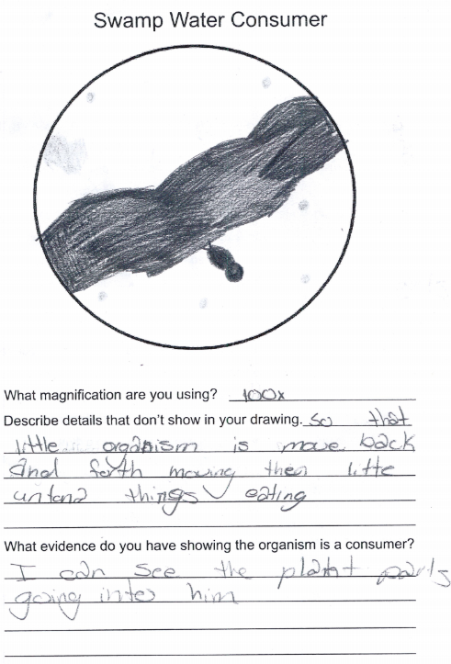
DCI | Proficient
Student demonstrates an understanding that a consumer often interacts with a plant by ripping off pieces to consume it.
CCC | Proficient
The student identifies an internal digestion system when they state seeing “the plant parts going in him”. Though this feature is found in some decomposers it is logical evidence this organism is a consumer.
SEP | Proficient
The student presents two pieces of evidence; ‘little antenna things eating’ and ‘plant parts going into him’ that support their claim their organism is a consumer.

Example 6
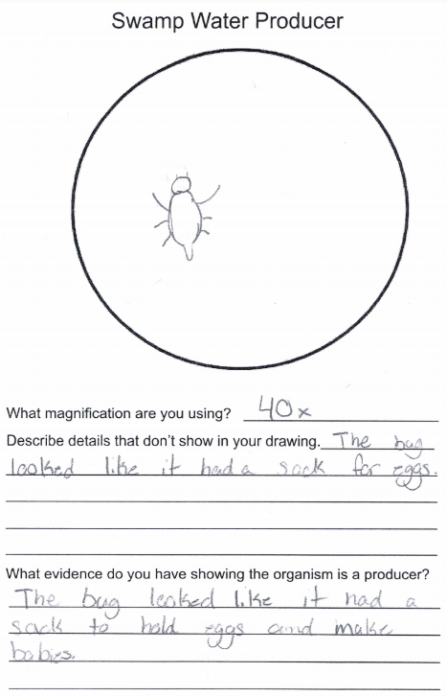
When assessing each standard, the evaluator should consider how consistently the student performs on each submission; producer, consumer, and decomposer. A student should be able to perform consistently to be considered proficient. Scores in the example below are based on the single submission.

DCI | Developing
Student does not base the organism’s classification on its interaction with the ecosystem.
CCC | Developing
The student’s observation of the organism's physical appearance demonstrates the student is conflating producers with an organism reproducing.
SEP | Proficient
The student’s observation of an egg sac is presented and clearly connected to their conclusion. Though the student has an obvious misconception of what a producer is, they do demonstrate an ability to present evidence for their conclusion. Their error demonstrates a lack of facts, not an inability to engage in argument from evidence.

