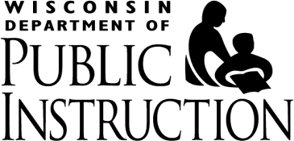
Tony Evers, PhD, State Superintendent

Date: May 24, 2016
To: Authorized Representatives of School Food Authorities (SFAs) Participating in the
U.S. Department of Agriculture (USDA) Child Nutrition Programs (CNPs)
From: Jessica Sharkus, RDN, CD
Director-School Nutrition Team (SNT)
Subject: Alternative School Food Authority Agreements
The Wisconsin Department of Public Instruction (DPI) SNT is dedicated to the health and well- being of all students in Wisconsin. This dedication to students is dependent on our ability to work with SFAs and to provide options that promote participation in the USDA CNPs. To ensure students have access to nutritious meals, we are announcing a new option to assist SFAs (and schools no longer participating) challenged with the administration of the CNPs.

An Alternate School Food Authority Agreement is an agreement between two SFAs or a SFA and a school, in which one SFA agrees to operate the school meal programs for a SFA/school not under its jurisdiction. By way of this agreement, the other SFA/school relinquishes its authority to operate the school meals programs and transfers legal and financial authority. The parties to this agreement agree to cooperate fully, to work in good faith, and to mutually assist each other in the performance of the agreement.

This is a great opportunity for public school districts to collaborate with local private schools that are challenged with or lack sufficient resources to manage the administrative piece of the CNPs. The SNT is fully supportive of this kind of collaboration; which is essential to providing these programs to more students.

Enclosed is a copy of a prototype that can be used for this type of agreement along with the terms of the agreement to be considered and/or negotiated between the two SFAs or a SFA and a school. Upon reviewing this option, if you feel this is something you would like to pursue, feel free to contact schools in your area. This information is also located on our website at http://dpi.wi.gov/school-nutrition/procurement.

We will be sending a similar memo to schools that have dropped the USDA Child Nutrition Programs over the last few years. Your SFA may be contacted by one of these schools.

Questions regarding this new option may be directed to the SNT at 608-267-9228.

PO Box 7841, Madison, WI 53707-7841  125 South Webster Street, Madison, WI 53703 (608) 266-3390  (800) 441-4563 toll free  dpi.wi.gov

