DETERMINING USDA FOODS PER MEAL CREDIT
FOR USE IN JOINT AGREEMENTS

Frequently, questions occur regarding the process to determine and establish the USDA Foods per meal credit for School Food Authorities (SFAs) that are entering into a Joint Agreement to provide meals to another SFA (Purchasing SFA). The SFA that is preparing the meals (Selling SFA) is responsible for determining and establishing the appropriate USDA Foods per meal credit to provide to the Purchasing SFA through a Joint Agreement. The following information is intended to provide guidance regarding the provision of the USDA Foods per meal credit in a Joint Agreement.

The information includes step-by-step instructions for determining the USDA Foods per meal credit. The instructions also reference how the numbers determined through these steps can be utilized to complete data on the Joint Agreement Template between the Selling SFA and the Purchasing SFA.

- Determining Baseline Cost Per Meal. Selling SFA must determine their baseline cost per meal. Costs should include both the food cost per meal and labor cost per meal. (See example page 3, Step 1).

This baseline cost per meal can be entered under the “Lunch: Price Per Meal” on page 1 of the Joint Agreement Template.

- Determining USDA Foods Per Meal Credit (2 Options). Selling SFA to determine the USDA Foods per meal credit to provide to the Purchasing SFA. Depending on the number of meals providing to this Purchasing SFA, the USDA Foods per meal credit may vary depending on the total entitlement value Selling SFA will be receiving on behalf of the Purchasing SFA. There are a couple of different methods that can be utilized to determine this USDA Foods per meal credit:

- If the Joint Agreement is being completed prior to the placement of the annual USDA Foods Order, the current School Year USDA Foods per meal rate provided in the Wisconsin USDA Foods Ordering System can be utilized as a starting point estimate. Also review the current year and any prior year (if available) USDA Foods entitlement data to determine if any increases/decreases may be necessary to this starting point estimate. (See example page 3, Step 2a)

- If the Joint Agreement is being completed after placement of the annual USDA Foods Order, the Selling SFA can use the USDA Foods per meal rate actually ordered for the Purchasing SFA. The USDA Foods per meal rate actually ordered can be determined by taking the total entitlement ordered for the Purchasing SFA in the Wisconsin USDA Foods Ordering System divided by the estimated total meals that Selling SFA will ship to the Purchasing SFA. If this is the first year that the Selling SFA will be providing meals to the Purchasing SFA, the Selling SFA will need to receive the estimated total meals from the Purchasing SFA. (See example page 3, Step 2b).

This USDA Foods per meal credit can be entered under the “Estimated USDA Foods Per Meal” on page 6 of the Addendum to Joint Agreement Template.

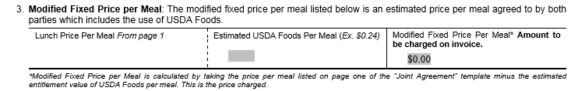

- Determining Modified Price Per Meal. To determine the modified price per meal, the USDA Foods per meal credit determined in #2 above will need to be subtracted from the baseline cost per meal determined in #1 above. This price represents the modified price per meal with the use of USDA Foods and represents the price per meal that the Selling SFA will be charging the Purchasing SFA. (See example page 3, Step 3).

On page 6 of the Addendum to Joint Agreement Template, the “Modified Fixed Price Per Meal” will automatically be calculated based on the “Lunch Price Per Meal” entered on page 1 and the “Estimated USDA Foods Per Meal” entered on page 6 of the Addendum to Joint Agreement Template.

- Year-End Reconciliation. A year-end reconciliation must also be completed to verify that the Selling SFA has provided the appropriate total entitlement credit to the Purchasing SFA. Based on the year-end reconciliation results, it may be necessary for the Selling SFA to provide crediting adjustments to the Purchasing SFA.

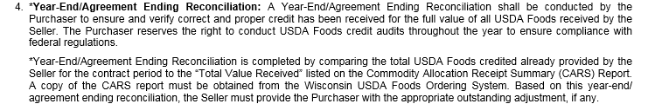

Instructions for completing the year-end reconciliation process are available on the Department of Public Instruction website: Crediting of USDA Foods Per Meal Credit.

Example for Establishing “Modified Fixed Price Per Meal”:

- Determining Baseline Cost Per Meal

Step 1:
$2.00 = Food Cost Per Meal
+$1.00 = Labor Cost Per Meal
$3.00 = Baseline Cost Per Meal

2. Determining USDA Foods Per Meal Credit (2 Options).

Step 2a:
Utilizing Current Year USDA Foods Rate
$.32 = USDA Foods Per Meal Credit

OR

Step 2b:
Utilizing Actual Entitlement Value Ordered
$5,000 = Actual Entitlement Dollar Ordered
÷15,625 = Estimated Total Meals to Ship
$.32 = USDA Foods Per Meal Credit

- Determining Modified Price Per Meal.

Step 3:
$3.00 = Baseline Cost Per Meal
-$.32 = USDA Foods Per Meal Credit
$2.68 = Modified Fixed Price Per Meal (price to charge receiving SFA)

